Luke Fox

Student ID: 30011364

COMP.6210

Web Application Design Assignment 1

Due Date 6 September 2019

PROJECT CODE CAFÉ

Table of Contents

Part A Design Document 3

Brief 3

Software Model: Agile 3

Scope 3

Part B: HiFi Wireframes: 4

Desktop and Tablet Hi-fi wireframes 4

Mobile Hi-Fi Wireframe – the responsive changes: 9

Extras: 10

SQL 11

ERD 13

Site Map of website showing links between pages 14

Mood board 14

Storyboard (sequence of events) 18

Flow diagram to show all the actions that can be taken on your site. 22

25

25

25

25

25

25

25

25

25

25

25

25

25

25

Part C: Testing Document 26

Reference 28

# Part A Design Document

## Brief

A soon to be owner (named Mr. He) of a café approached me wanting a website made. Here is the criteria:

It will be in Tauranga constructed in an old wood style. He wants to attract programmers and 3d model artists, basically people that work from their laptops and will stay in the café a long time to buy his home made food and drink his coffee.

From the photos given to me, as web developer I show him my high-fidelity design and mood board to see if he likes it. He does and the project is a go.

## Software Model: Agile

I explain to him the Agile model and how I will keep him updated.

Agile SDLC works a lot like a train. Each rotation of the train wheels represents a sprint. During each sprint rotation, new needs such as a menu change are coming in from the backlog. The website is iterated through once a fortnight with me for the first or first and second time. Then, you are on your own. You are the wheels and I am the train driver, making sure the website is running over a long period of time while you make change over short periods of time (Synopsys, 2019).

The next catch up, he explained he wanted full rain of the website except the navbar and header, he liked them. To do this. Once he is logged in. There will be an edit button for him to edit the pages.

## Scope

I will use Bootstrap framework because they use PHP for their backend and there is lots of support. I will use PHPmyAdmin, and Apache from XAMPP. A high-fidelity wireframe and mood-board to show design; and storyboard, and flow-diagram owner the functionality (first stage in agile cycle, pre-production).

The scope also consists of seven pages. A home page with opening hours; a login page and a register page for the owner; a menu page; a form page to get in contact with the owner (name, email, message); a feedback and rating page that will be approved by owner; and a page to send messages without logging in but the owner must approve the message before it is displayed via visitor email. The owner will be able to edit the whole site except header and nav-bar. PHP will be added to make this happen.

Also, the website will be responsive so that the whole site can be read from a mobile phone.

# Part B: HiFi Wireframes:

## Desktop and Tablet Hi-fi wireframes

Desktop Tablet

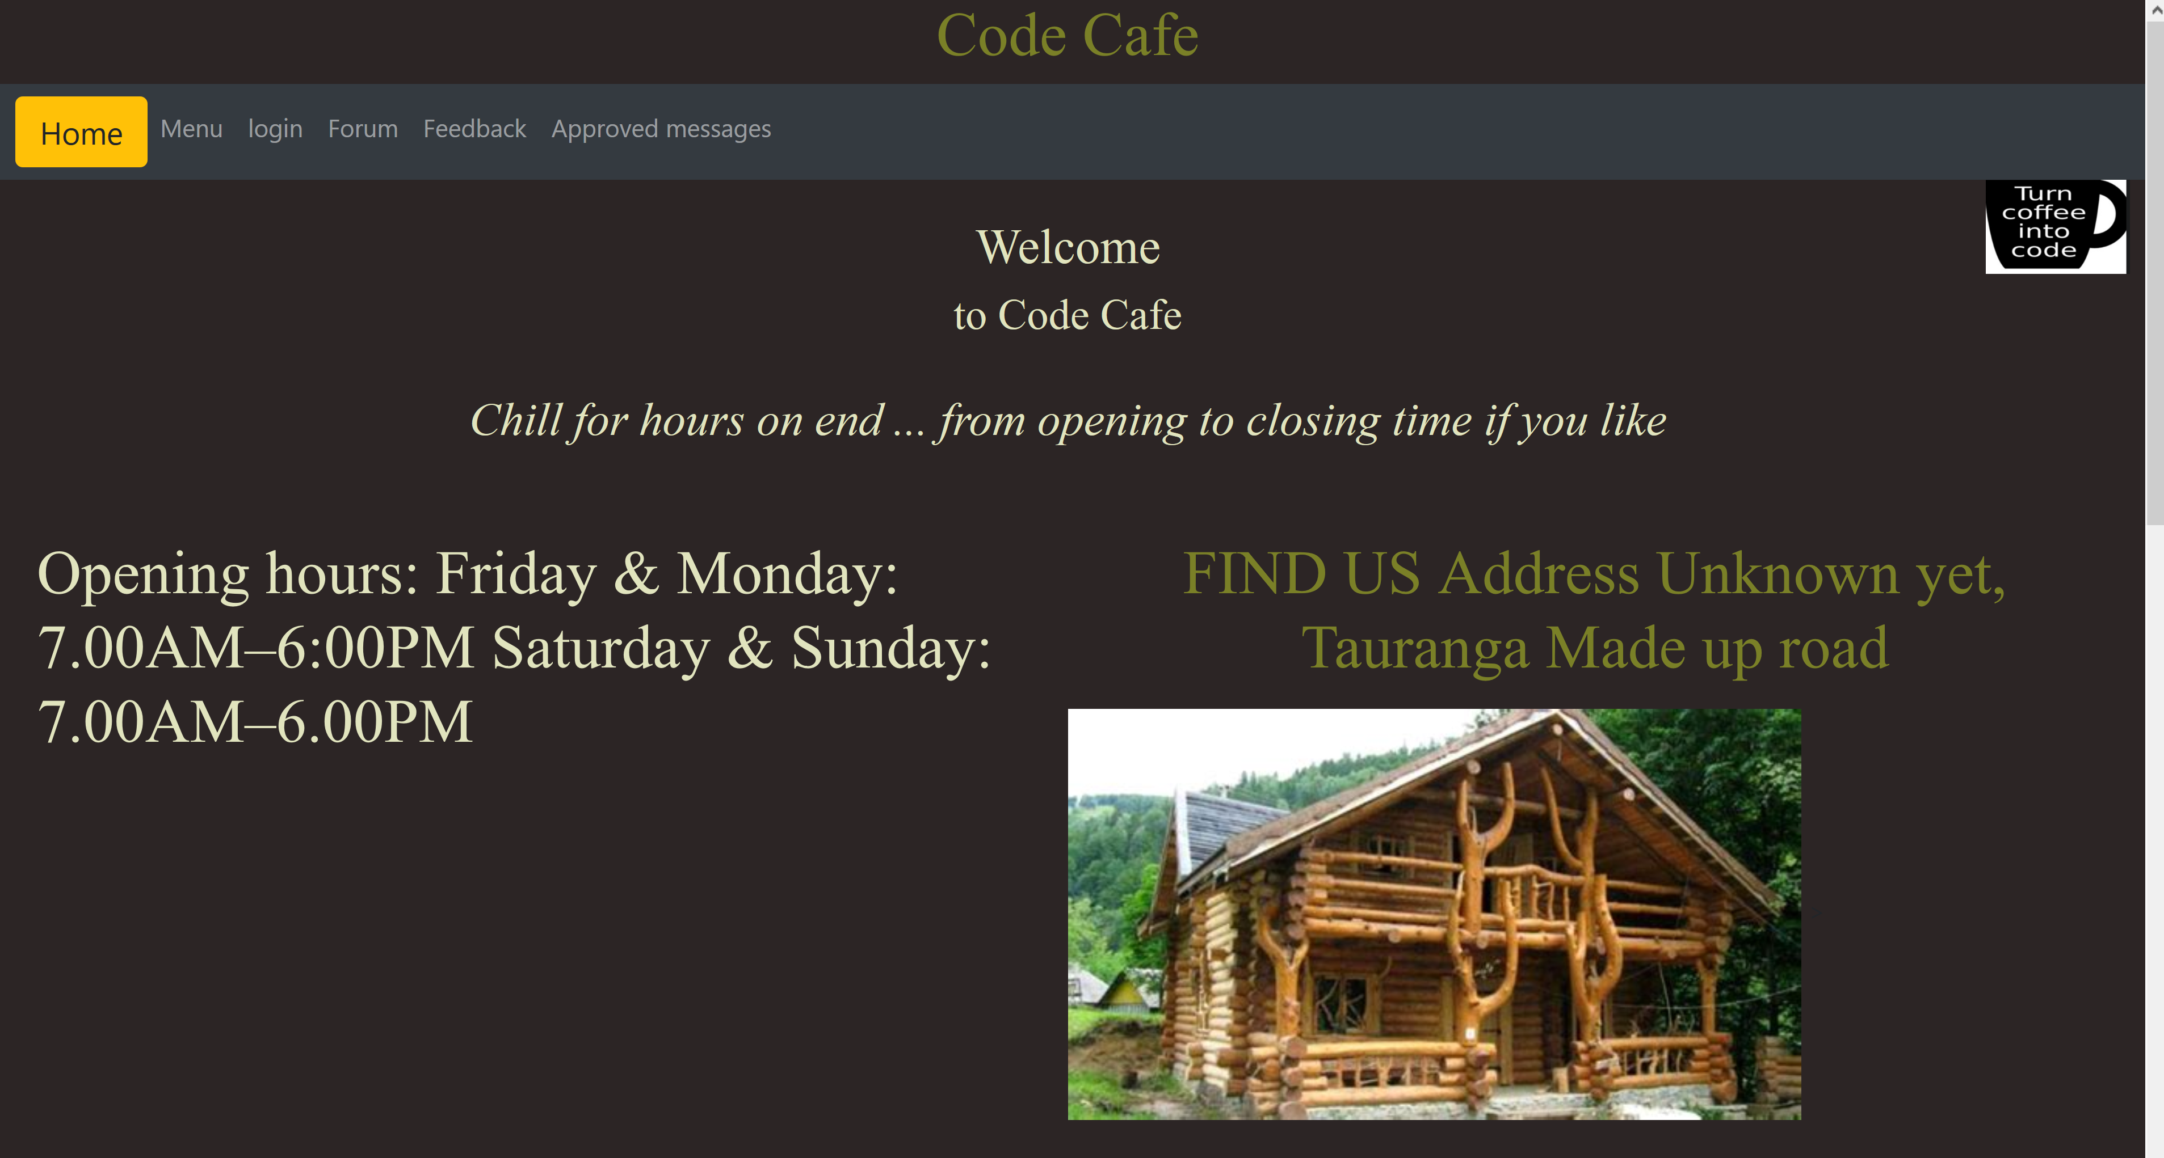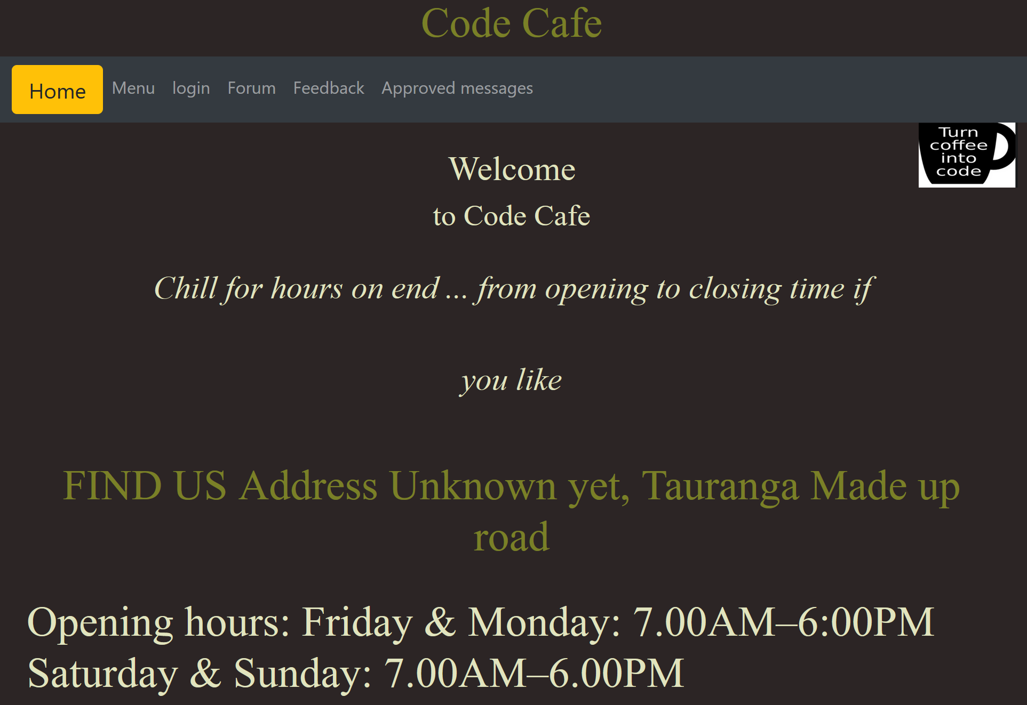

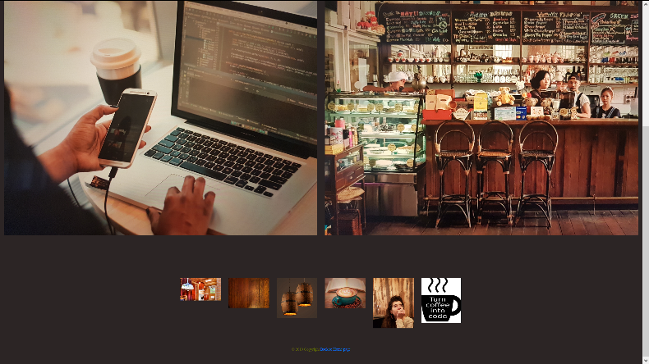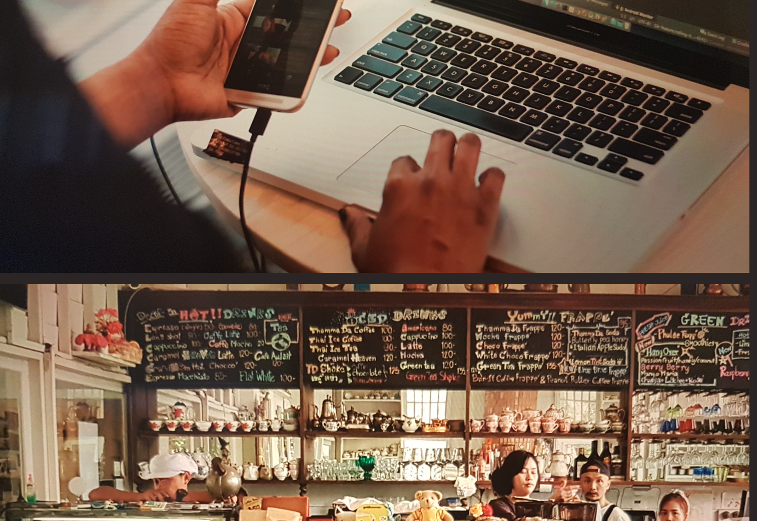

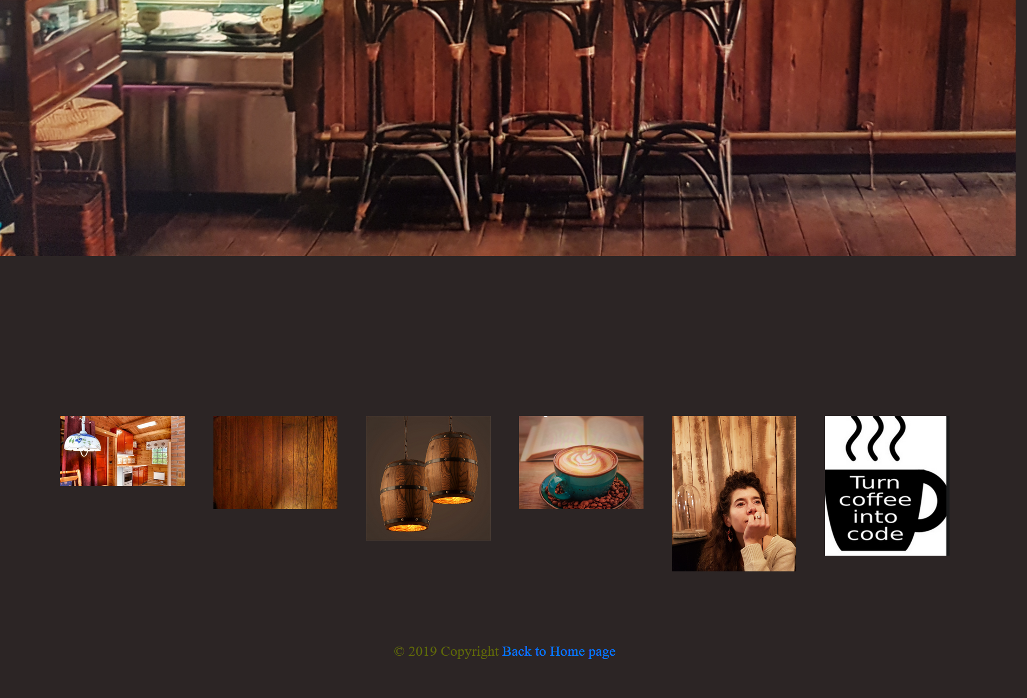

Menu Desktop: Menu: Tablet

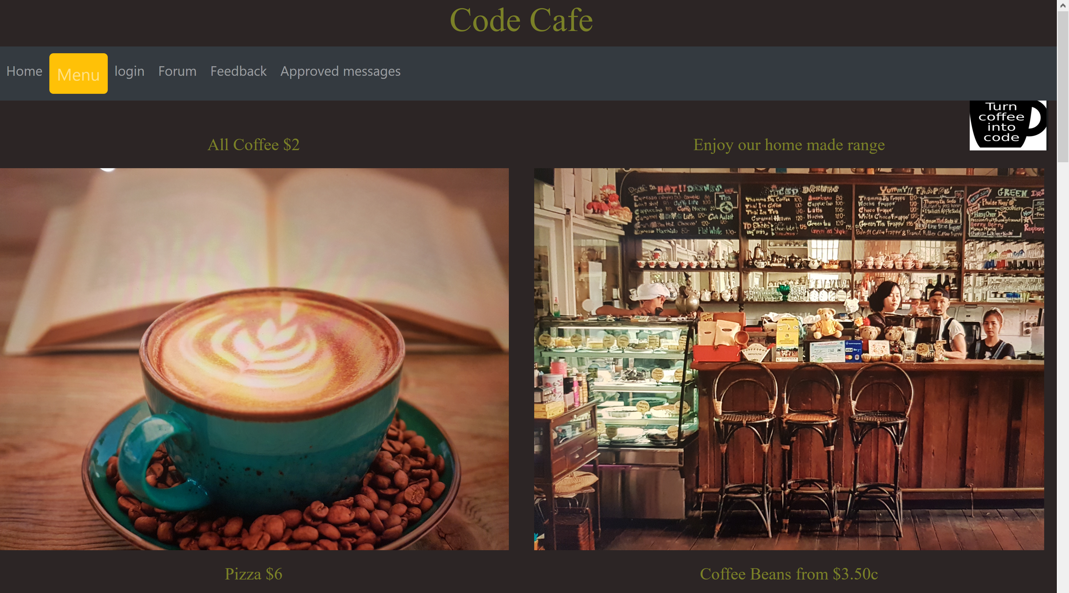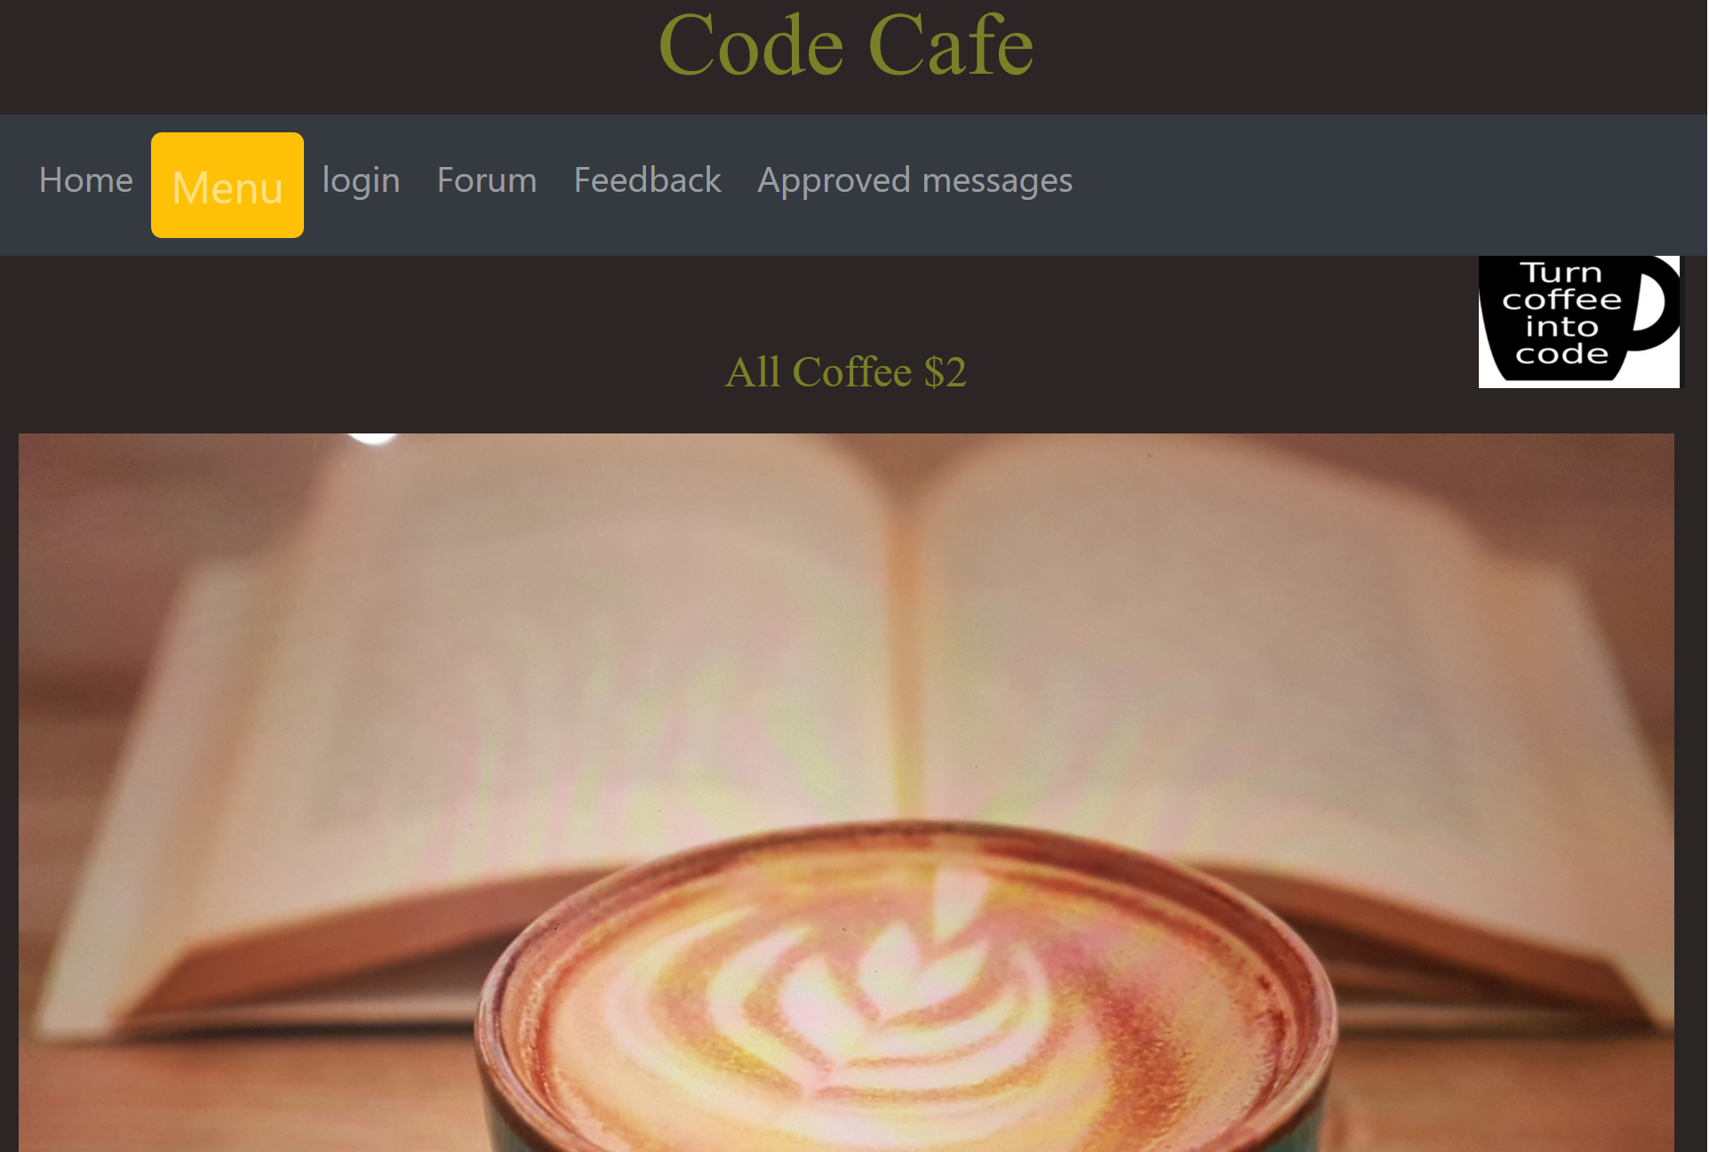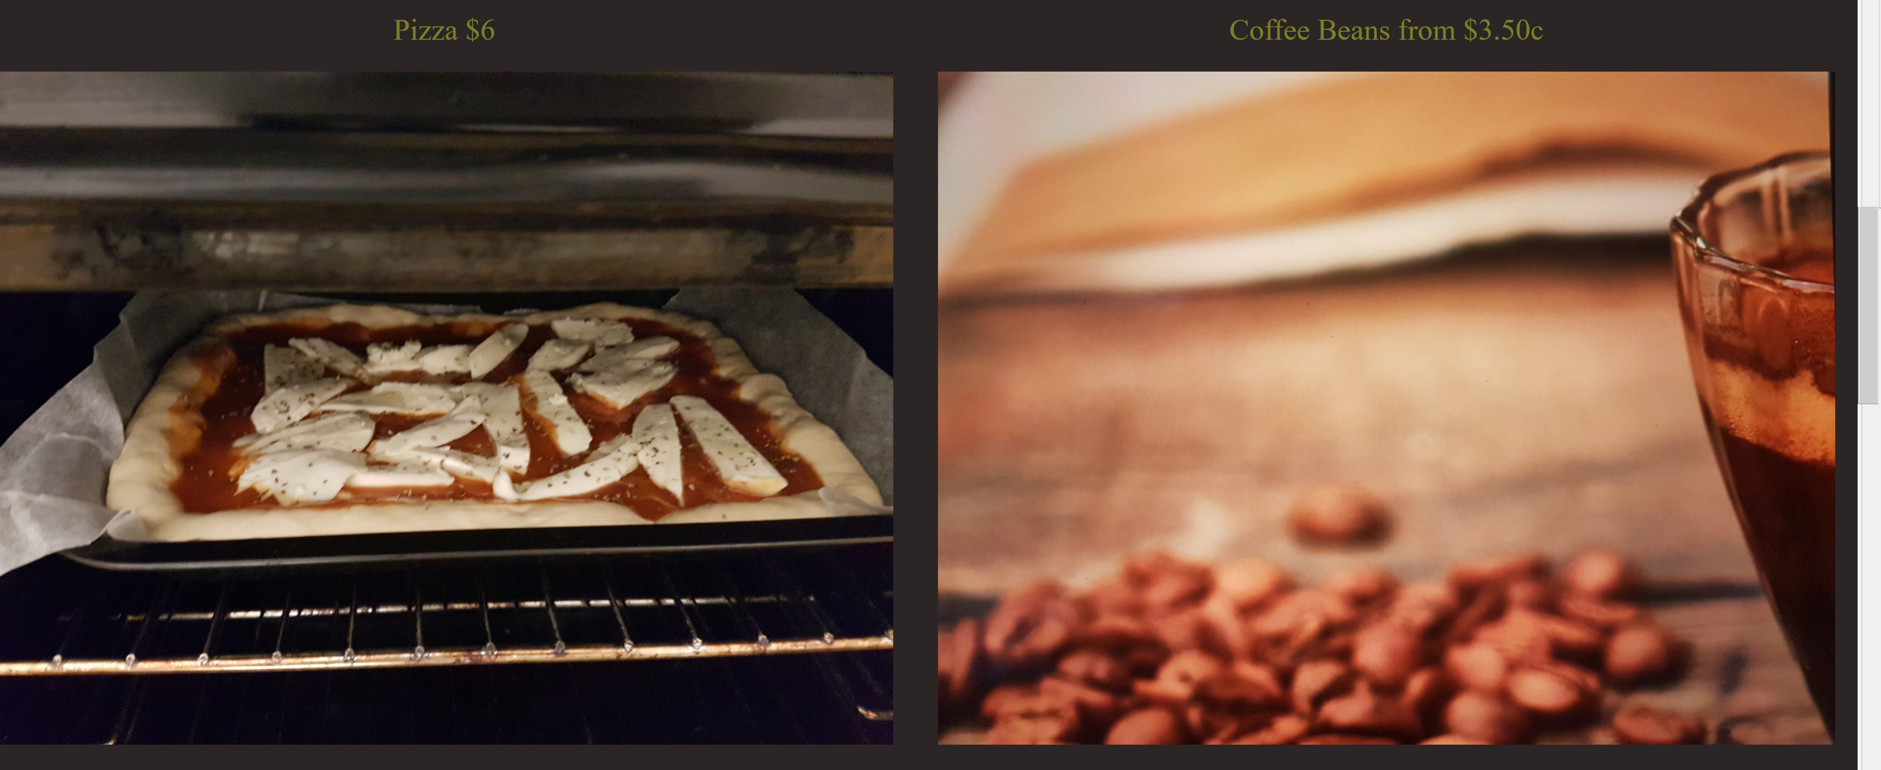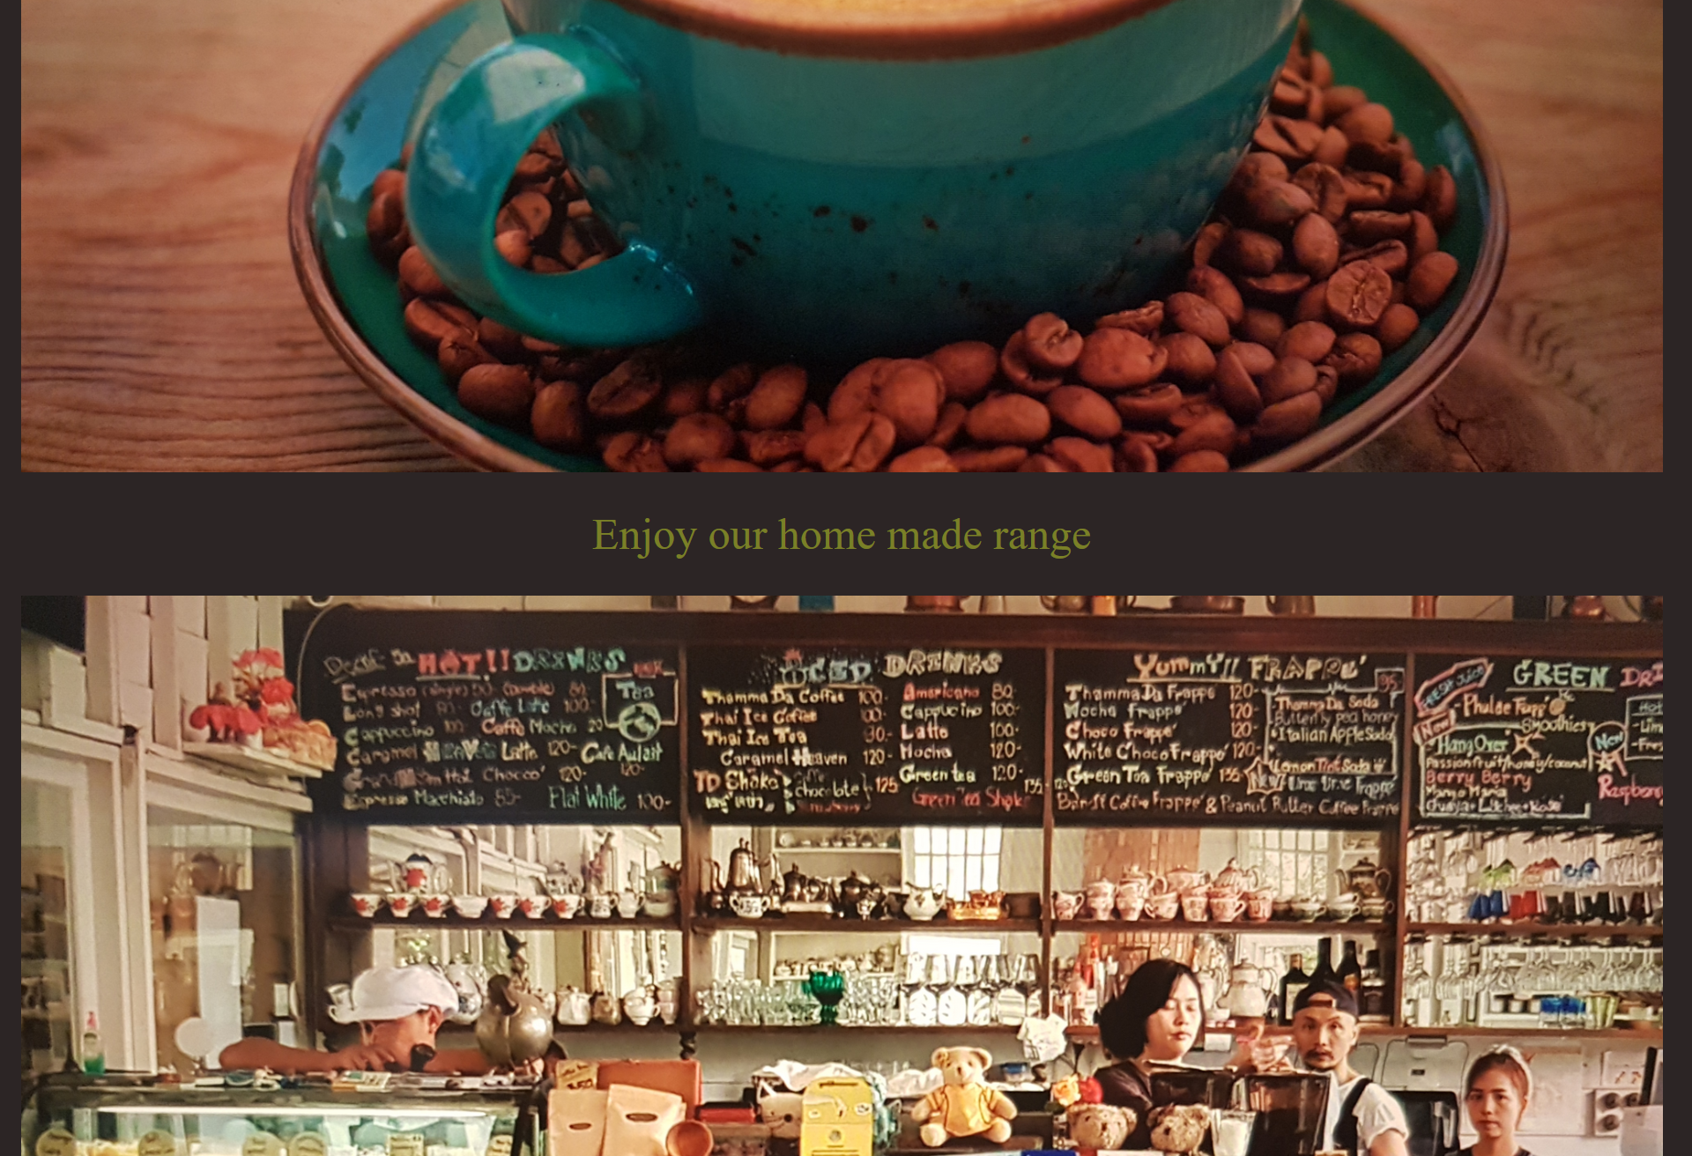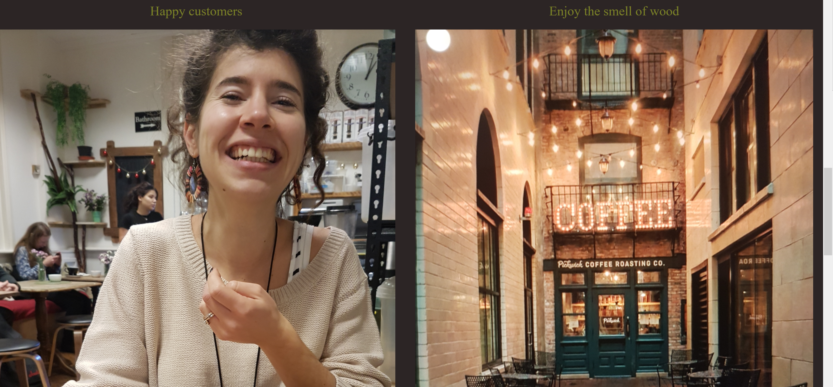 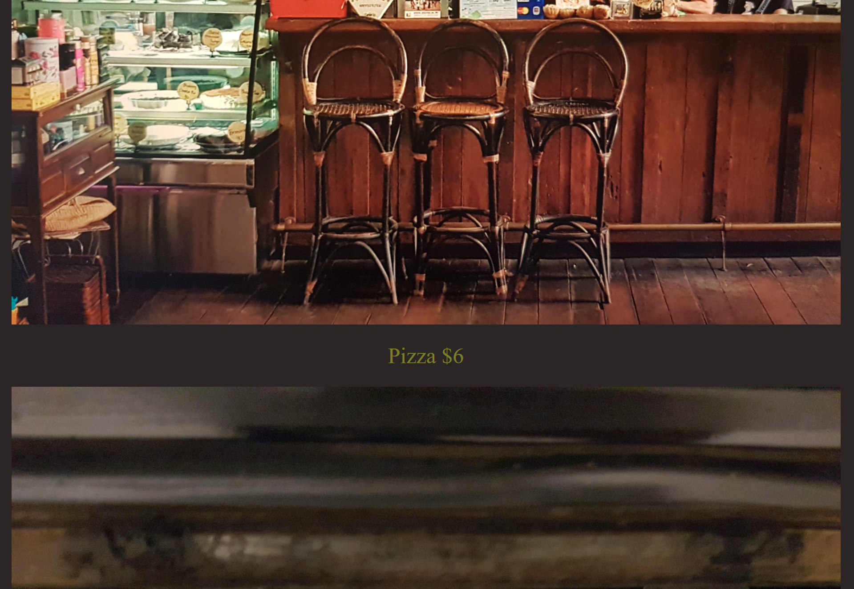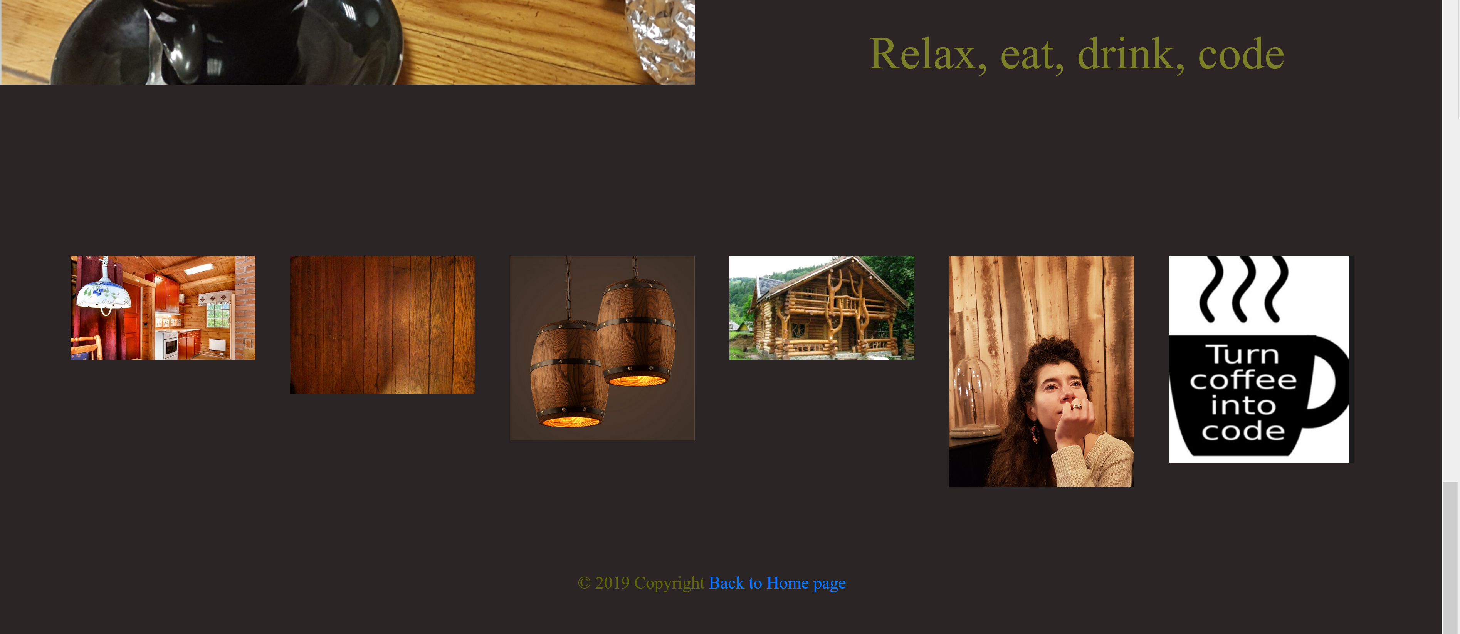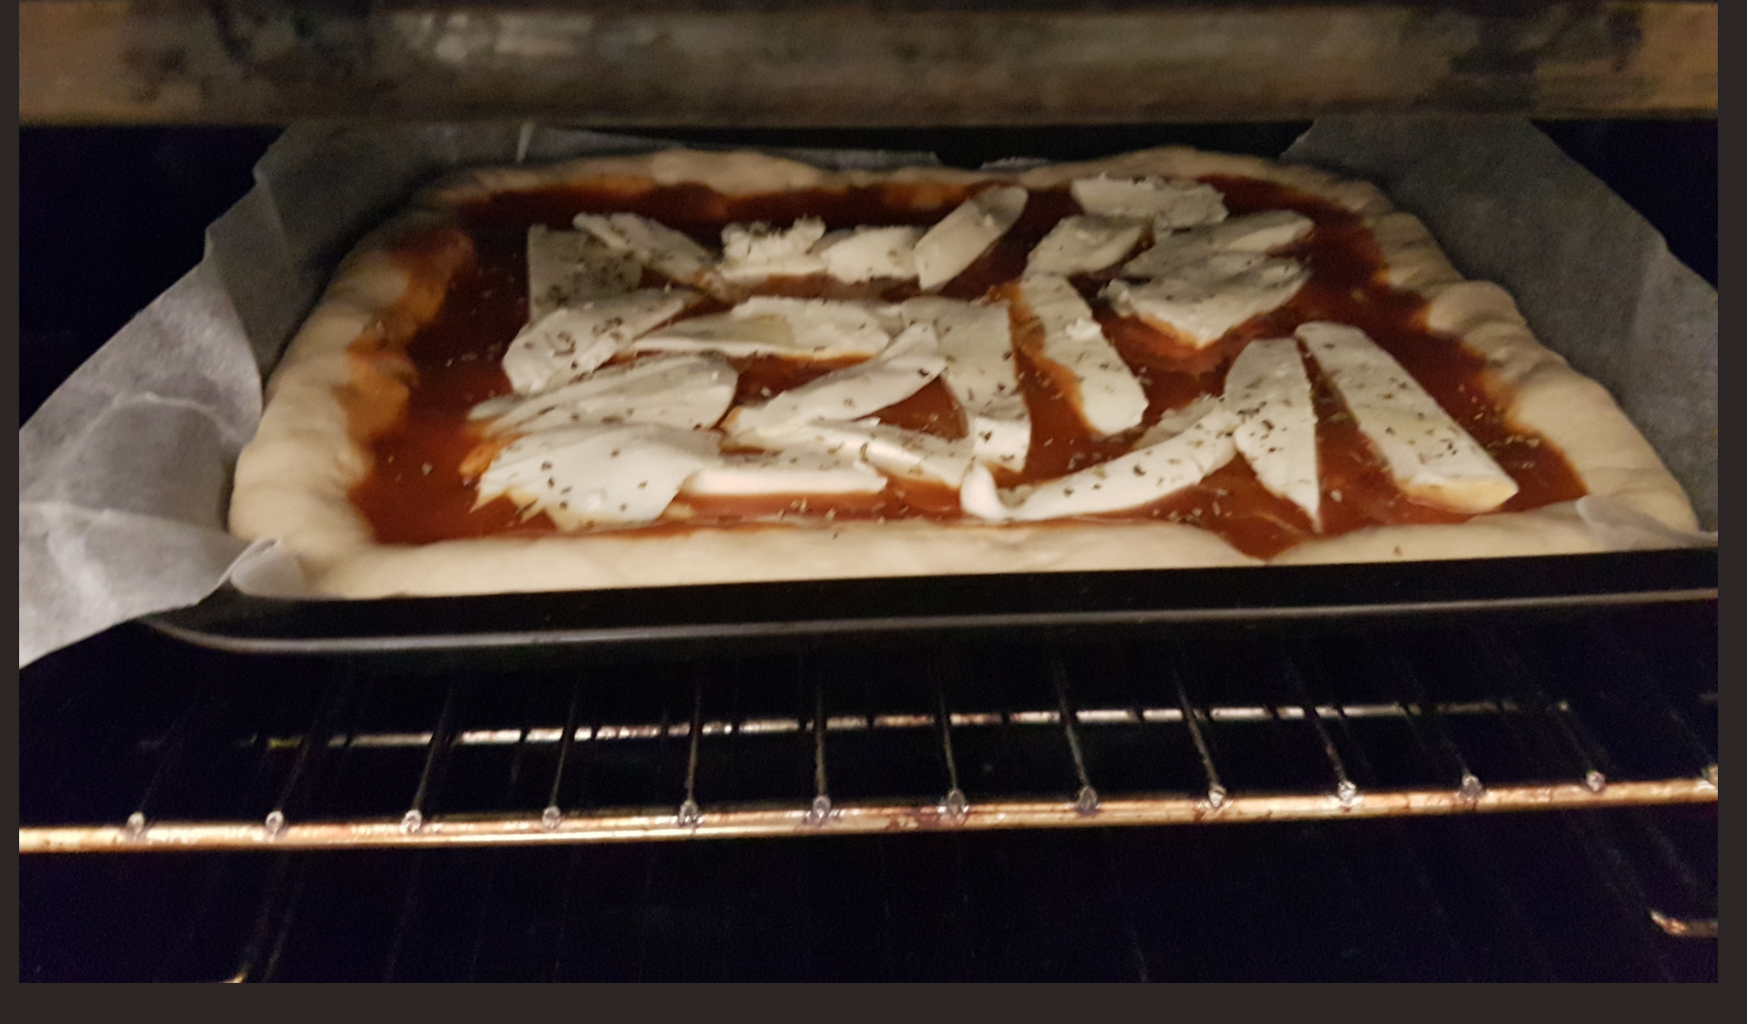

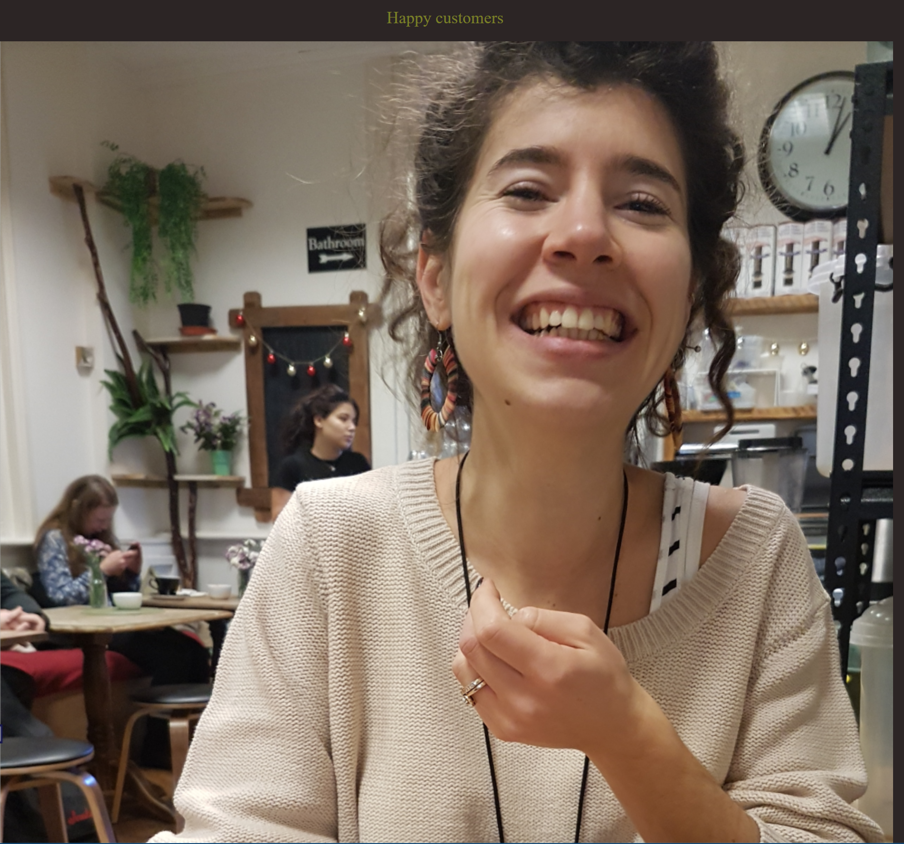

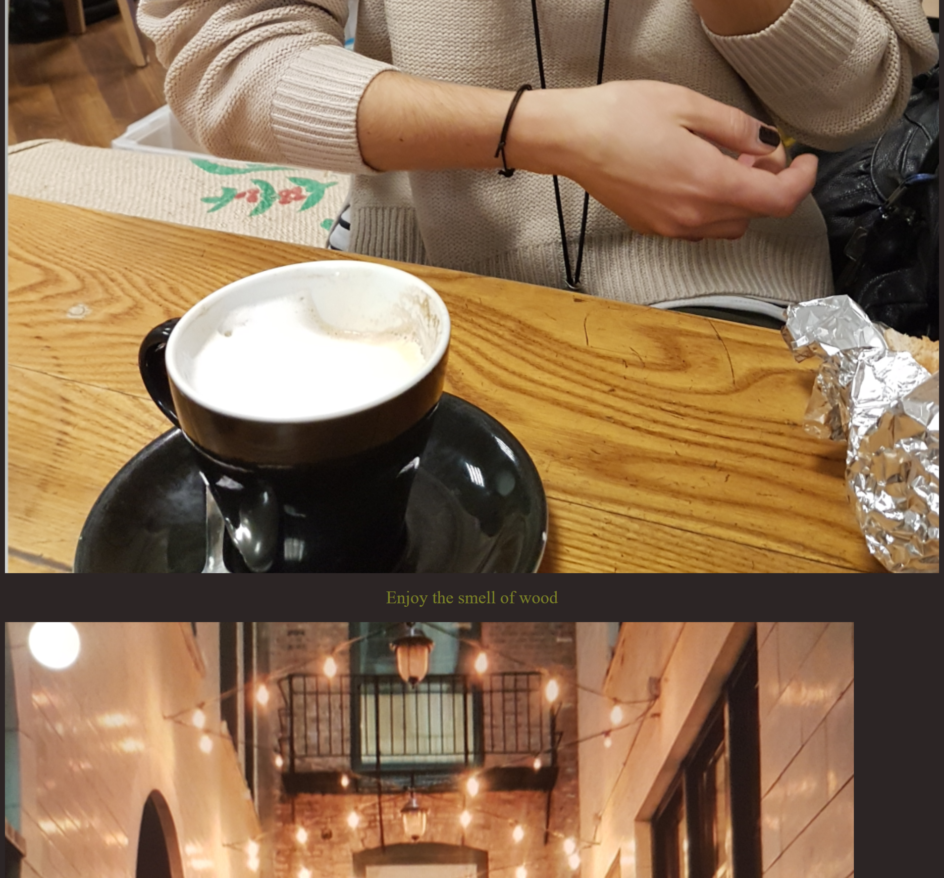

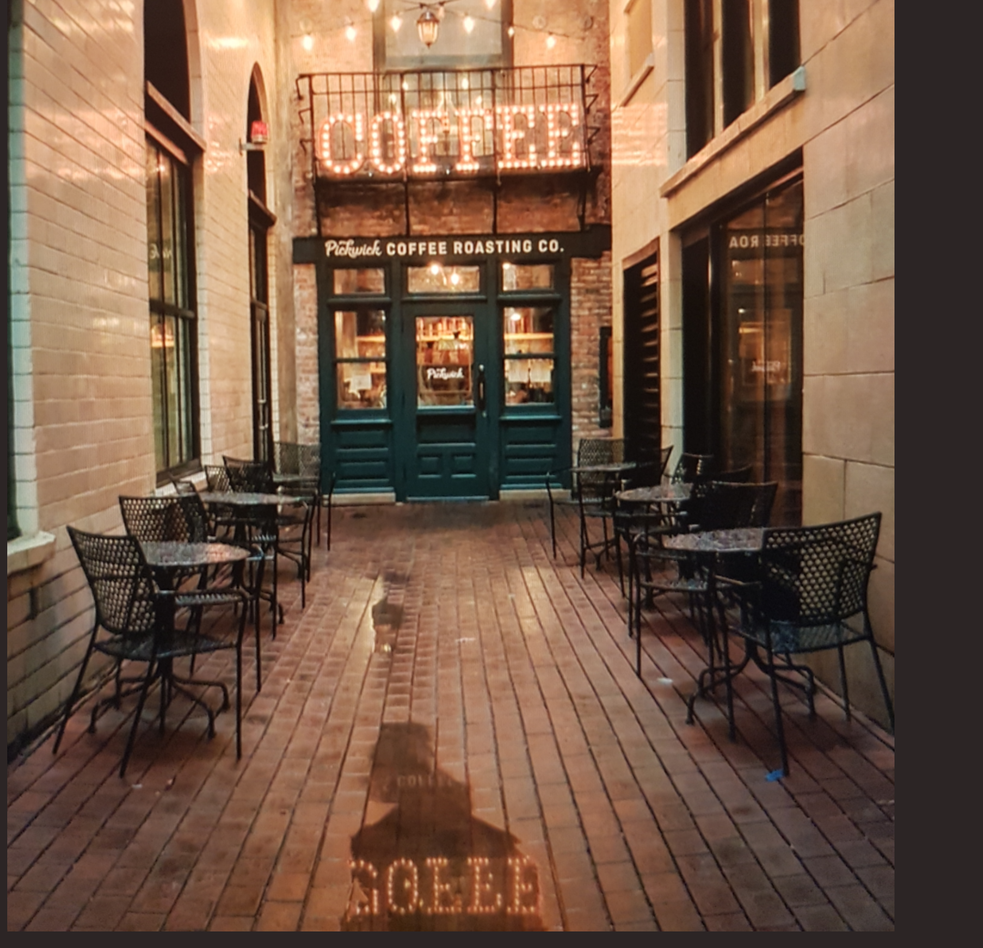

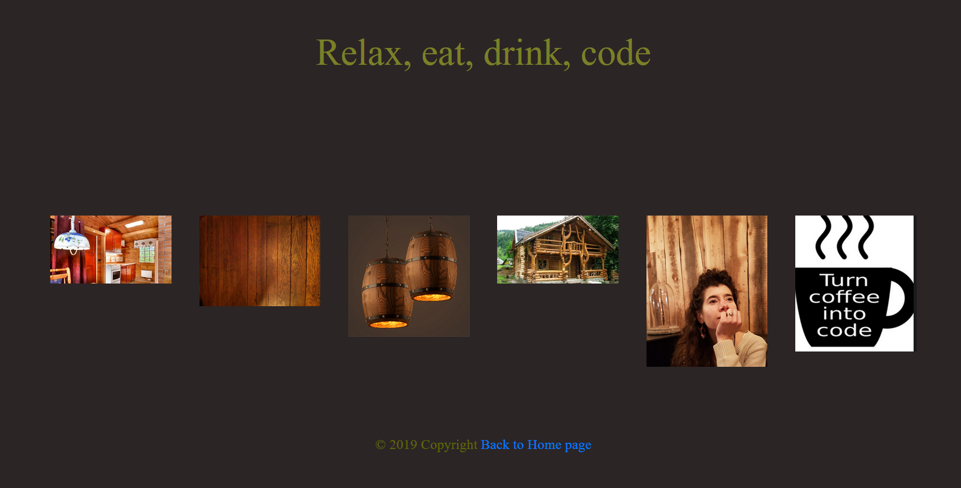

Desktop Login: Tablet Login:

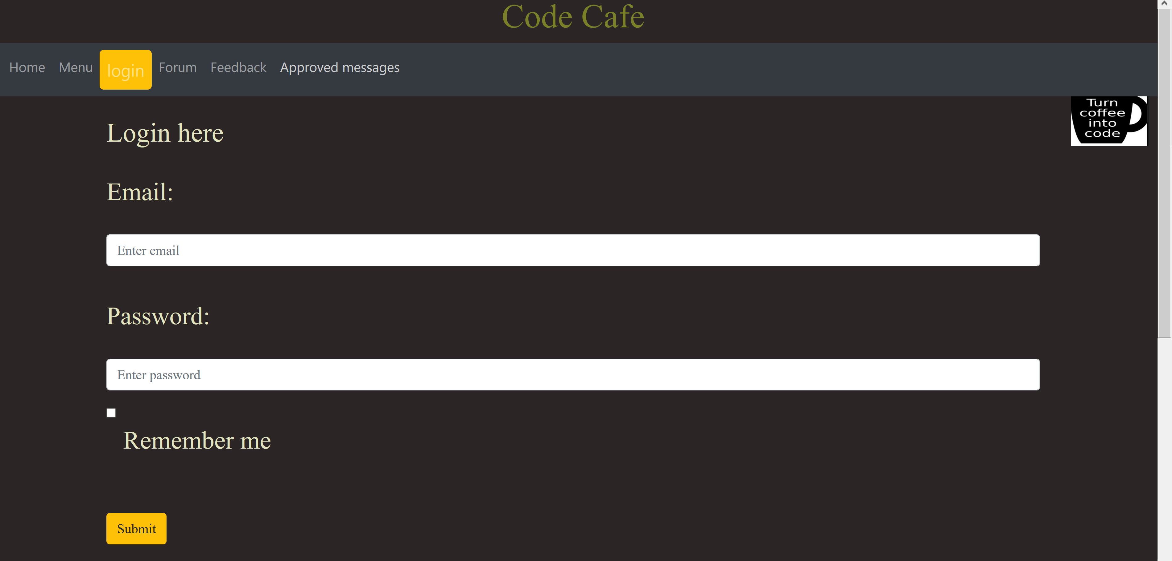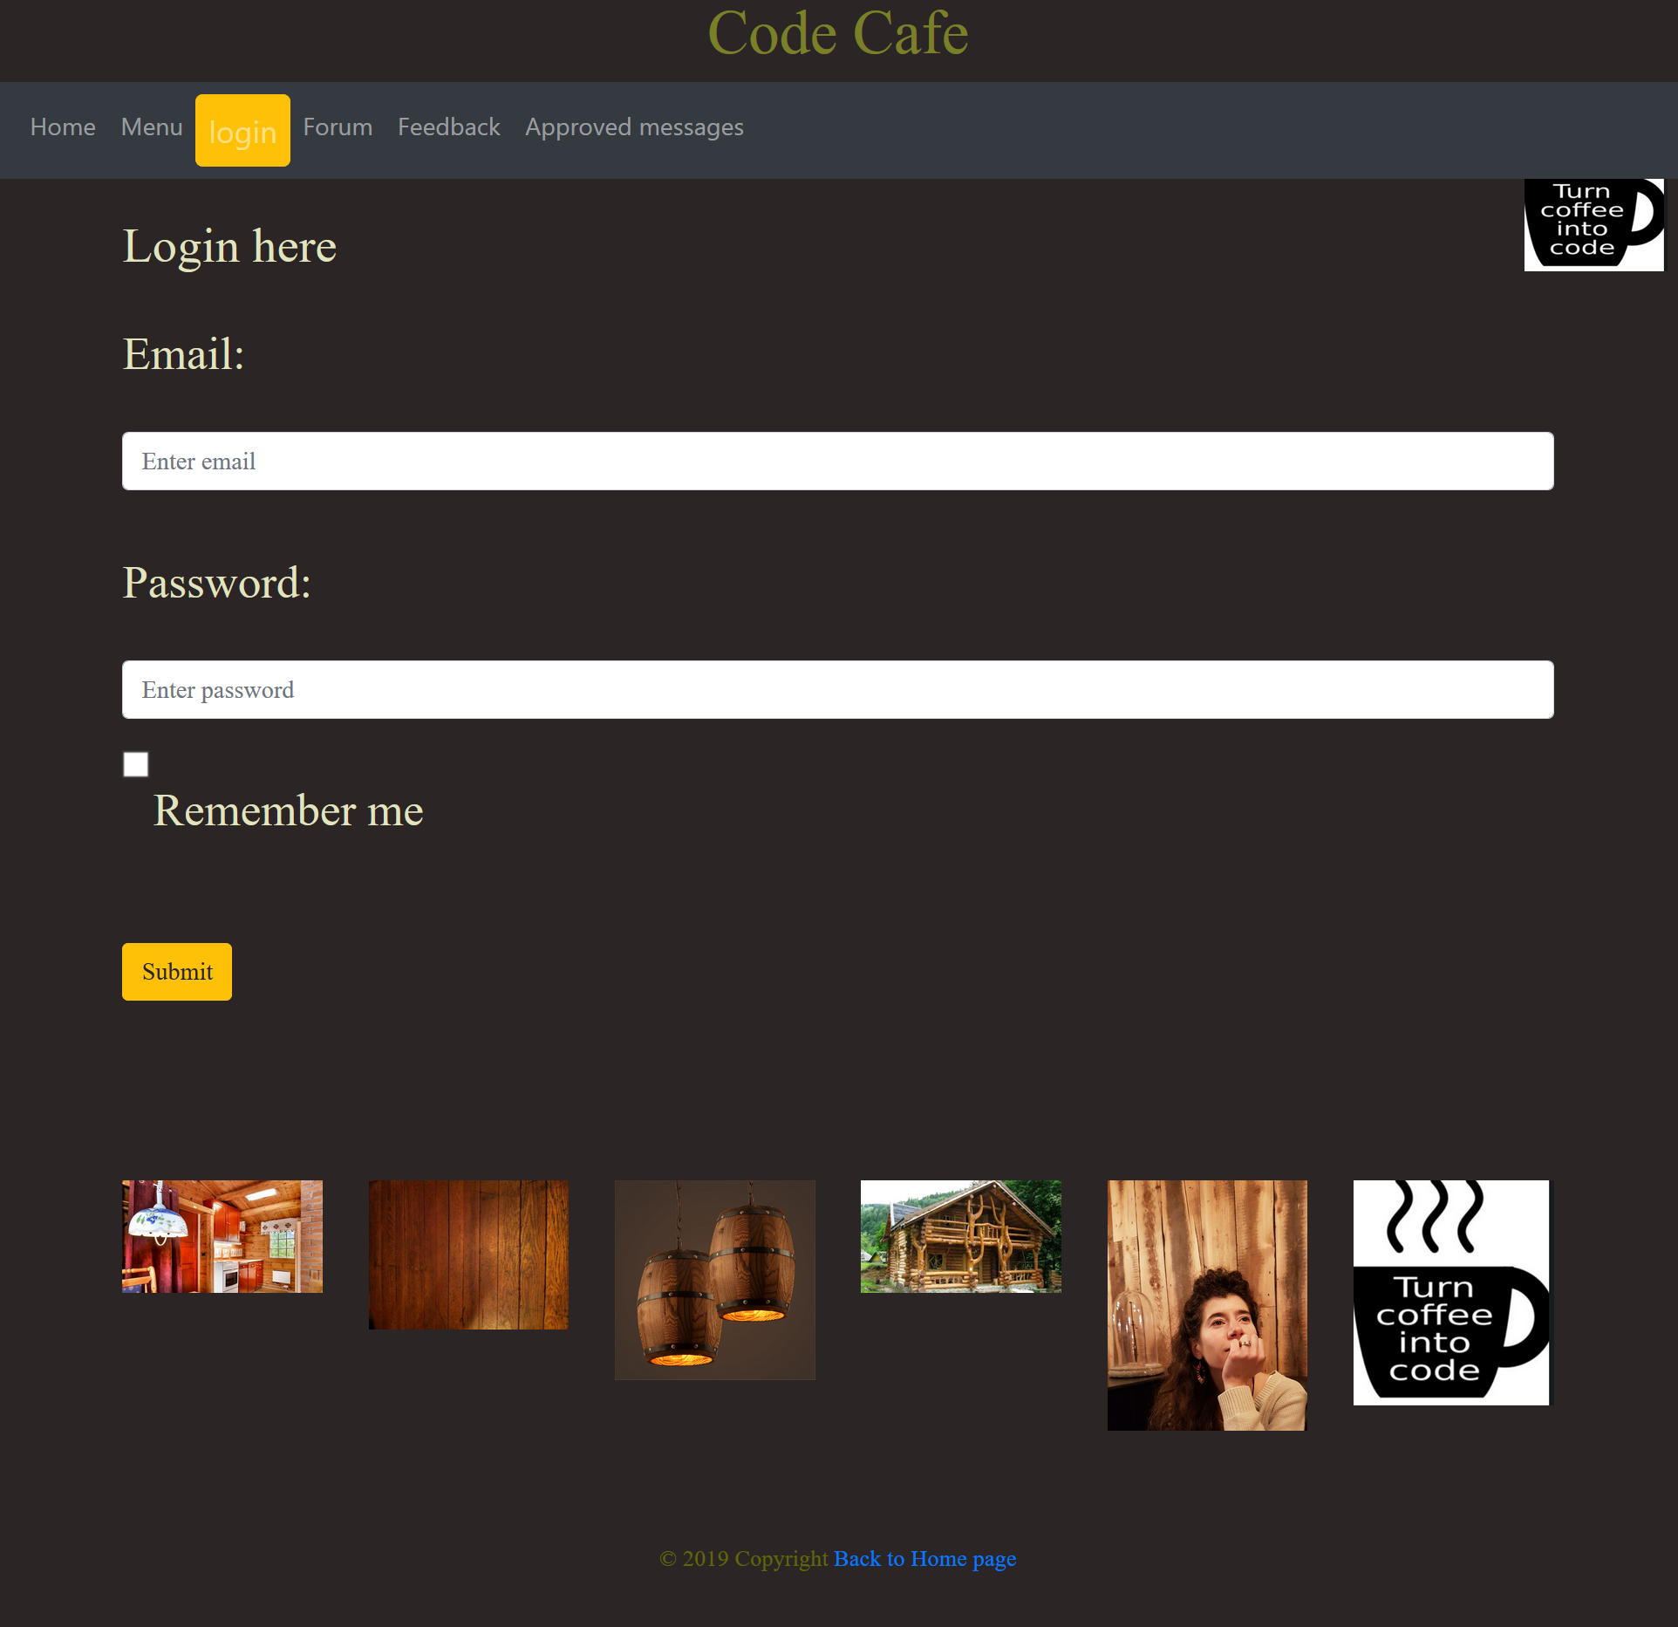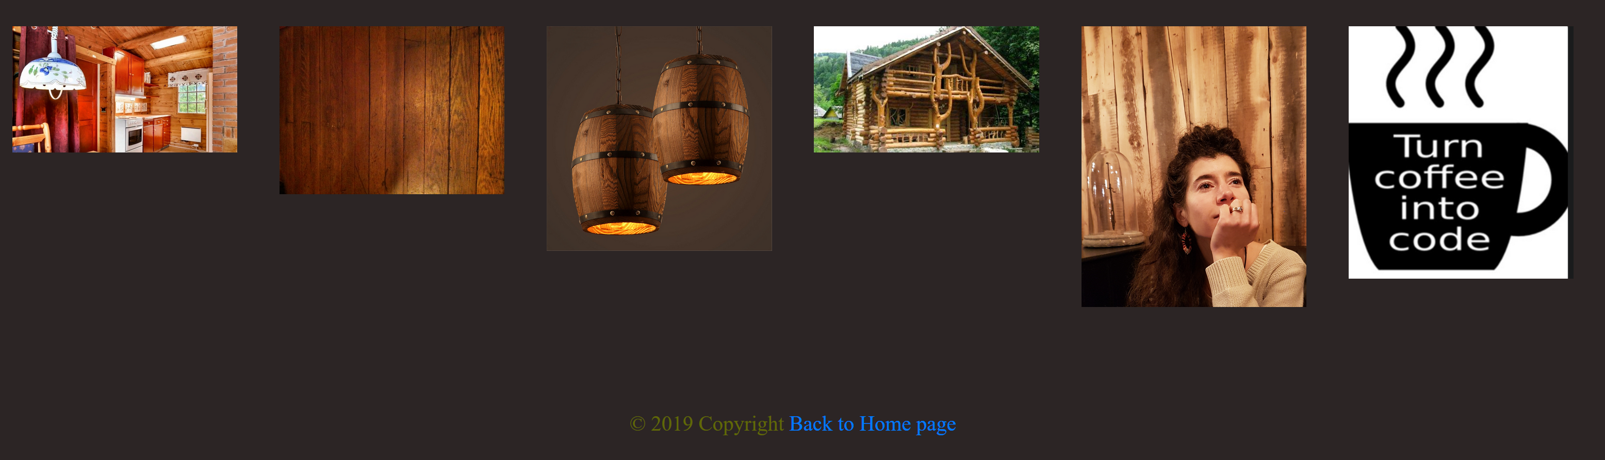

Desktop Forum: Tablet Forum:

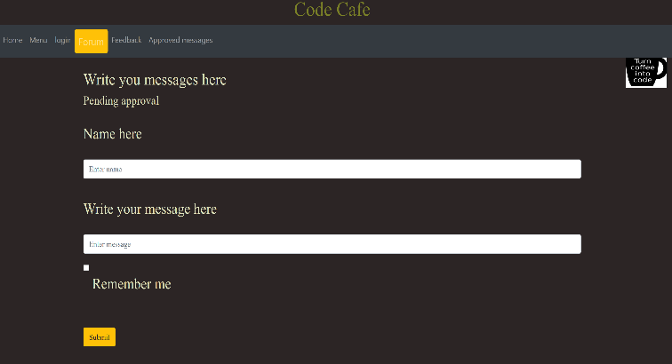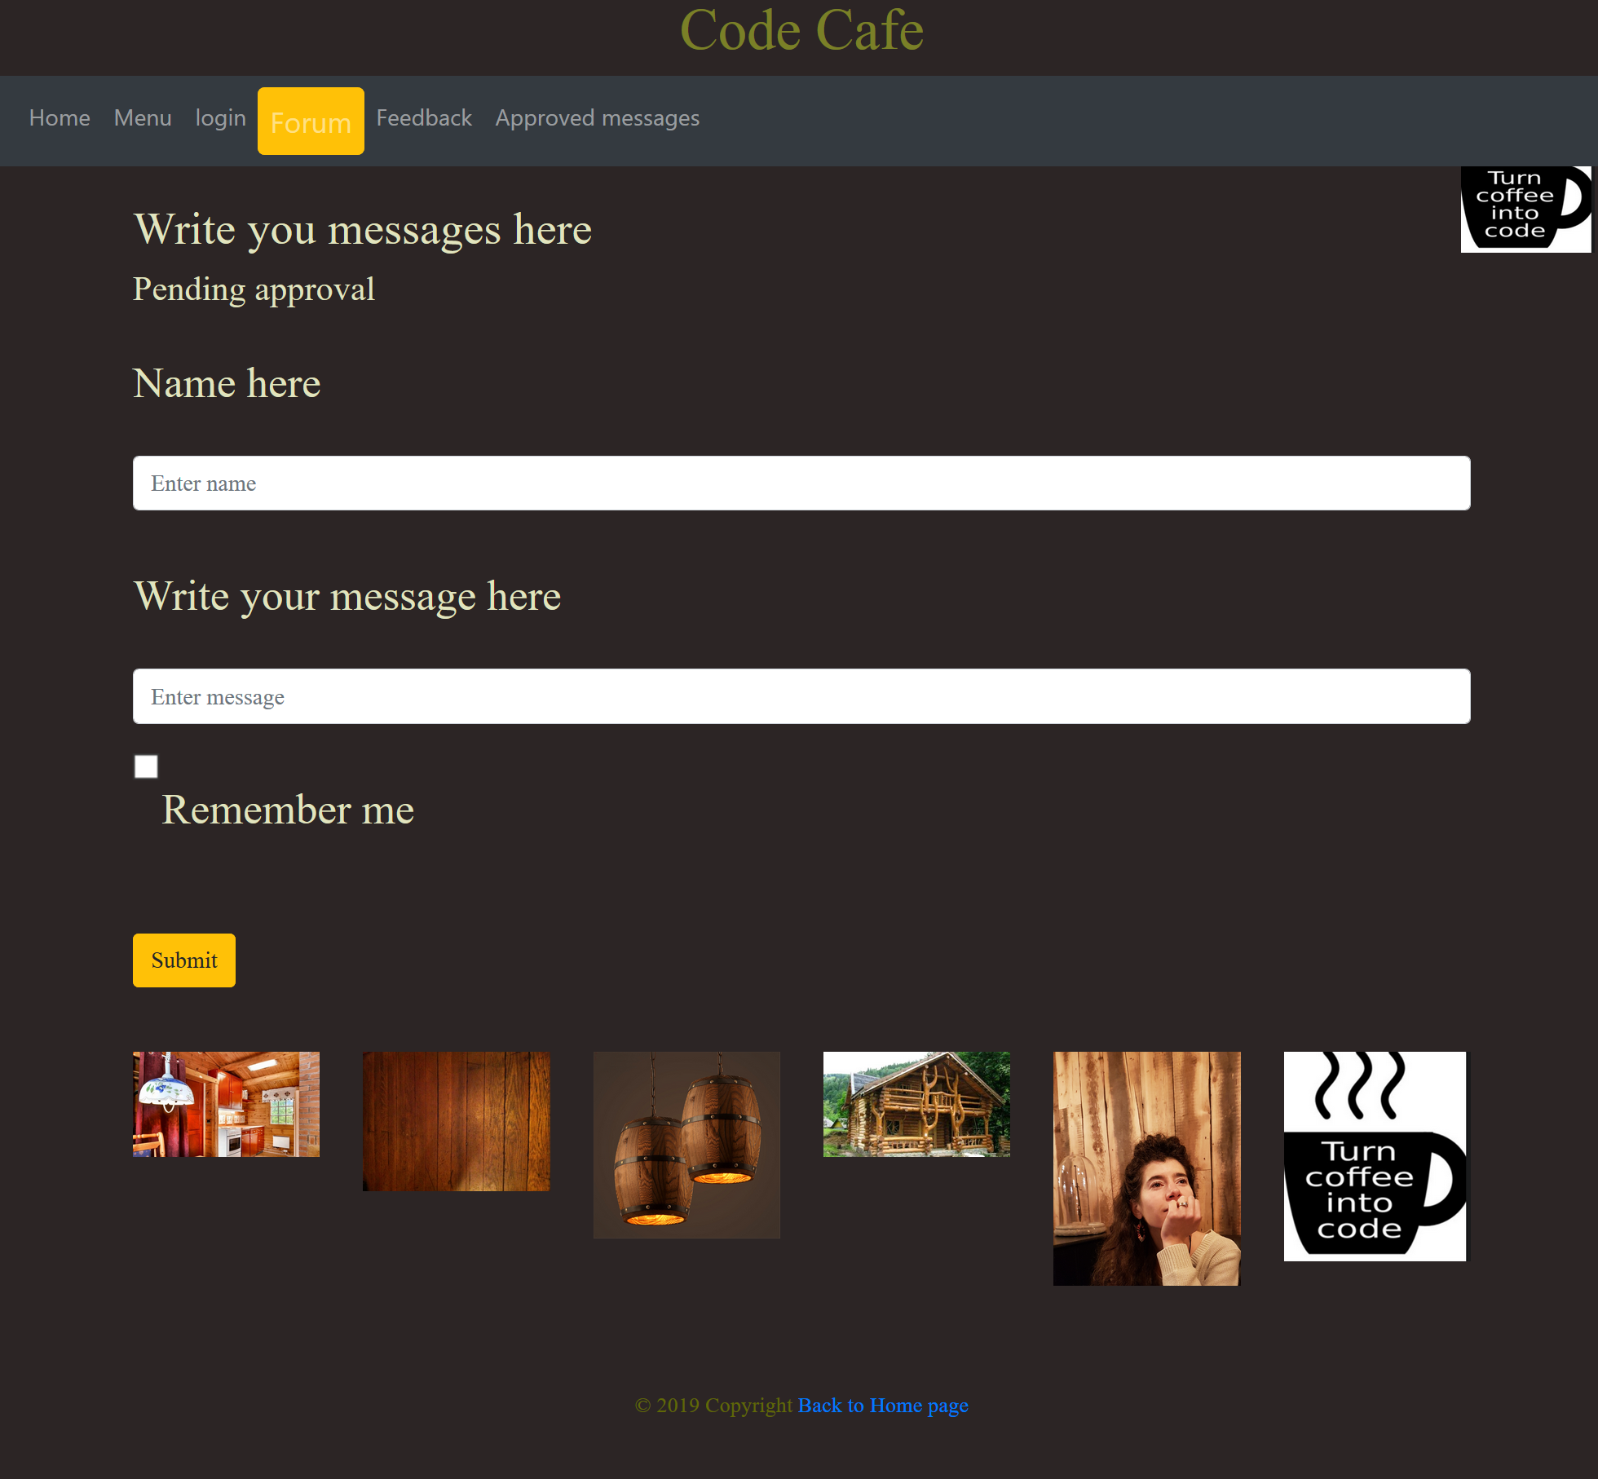

Desktop Feedback:

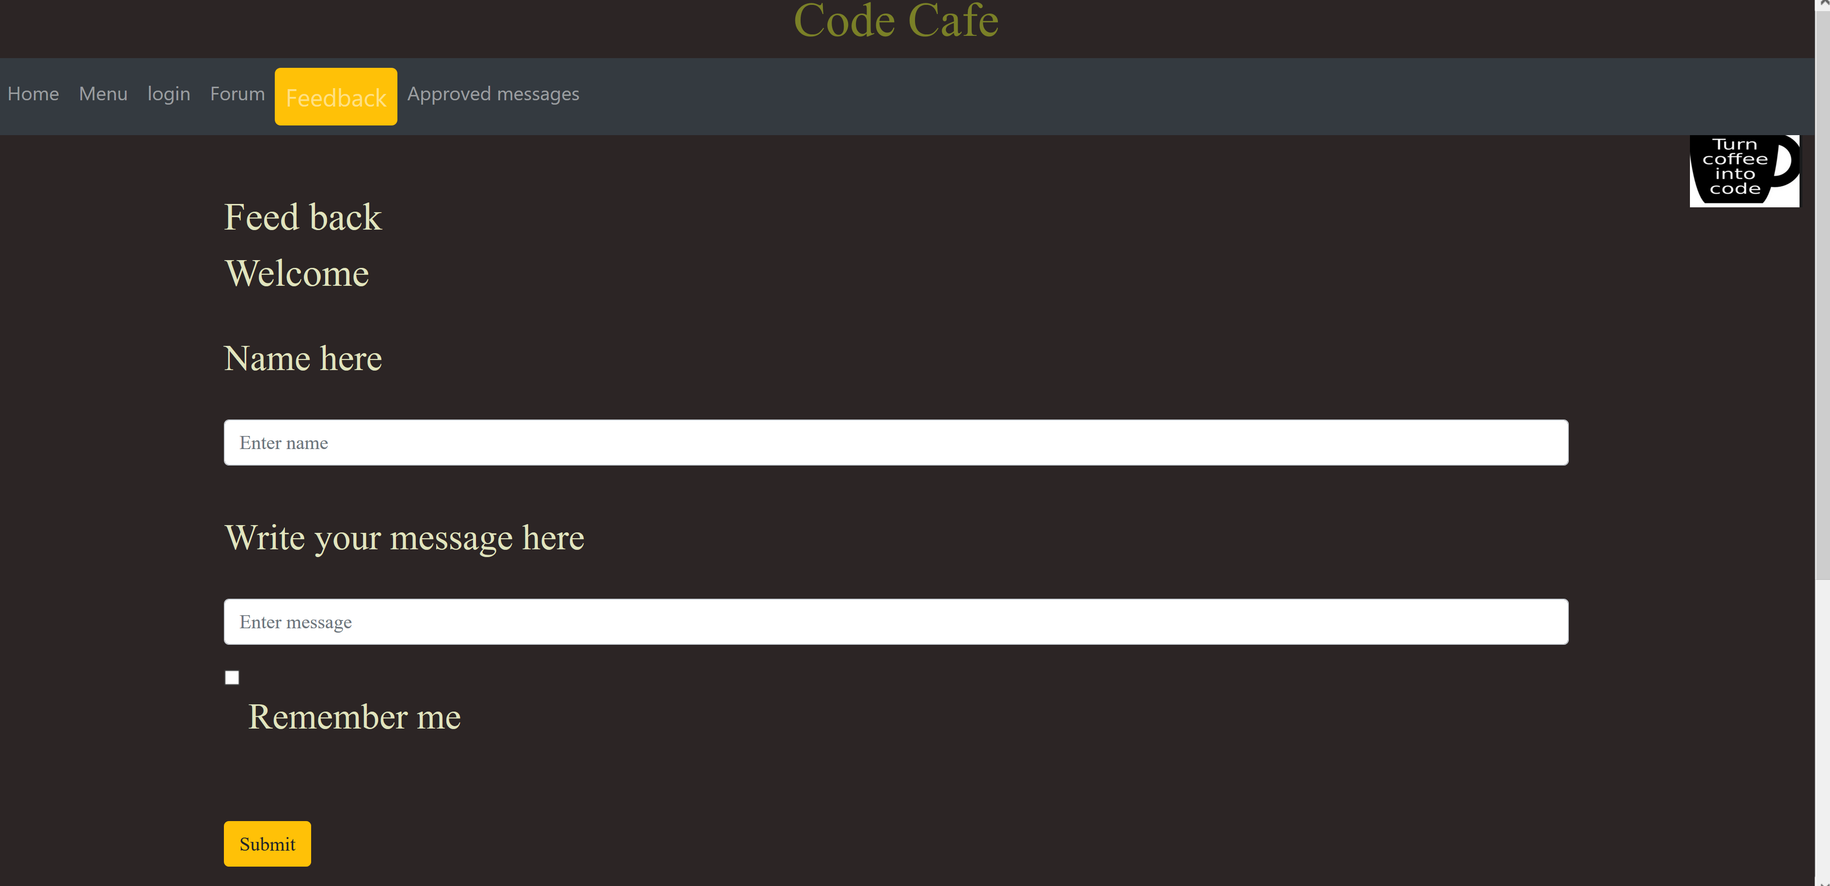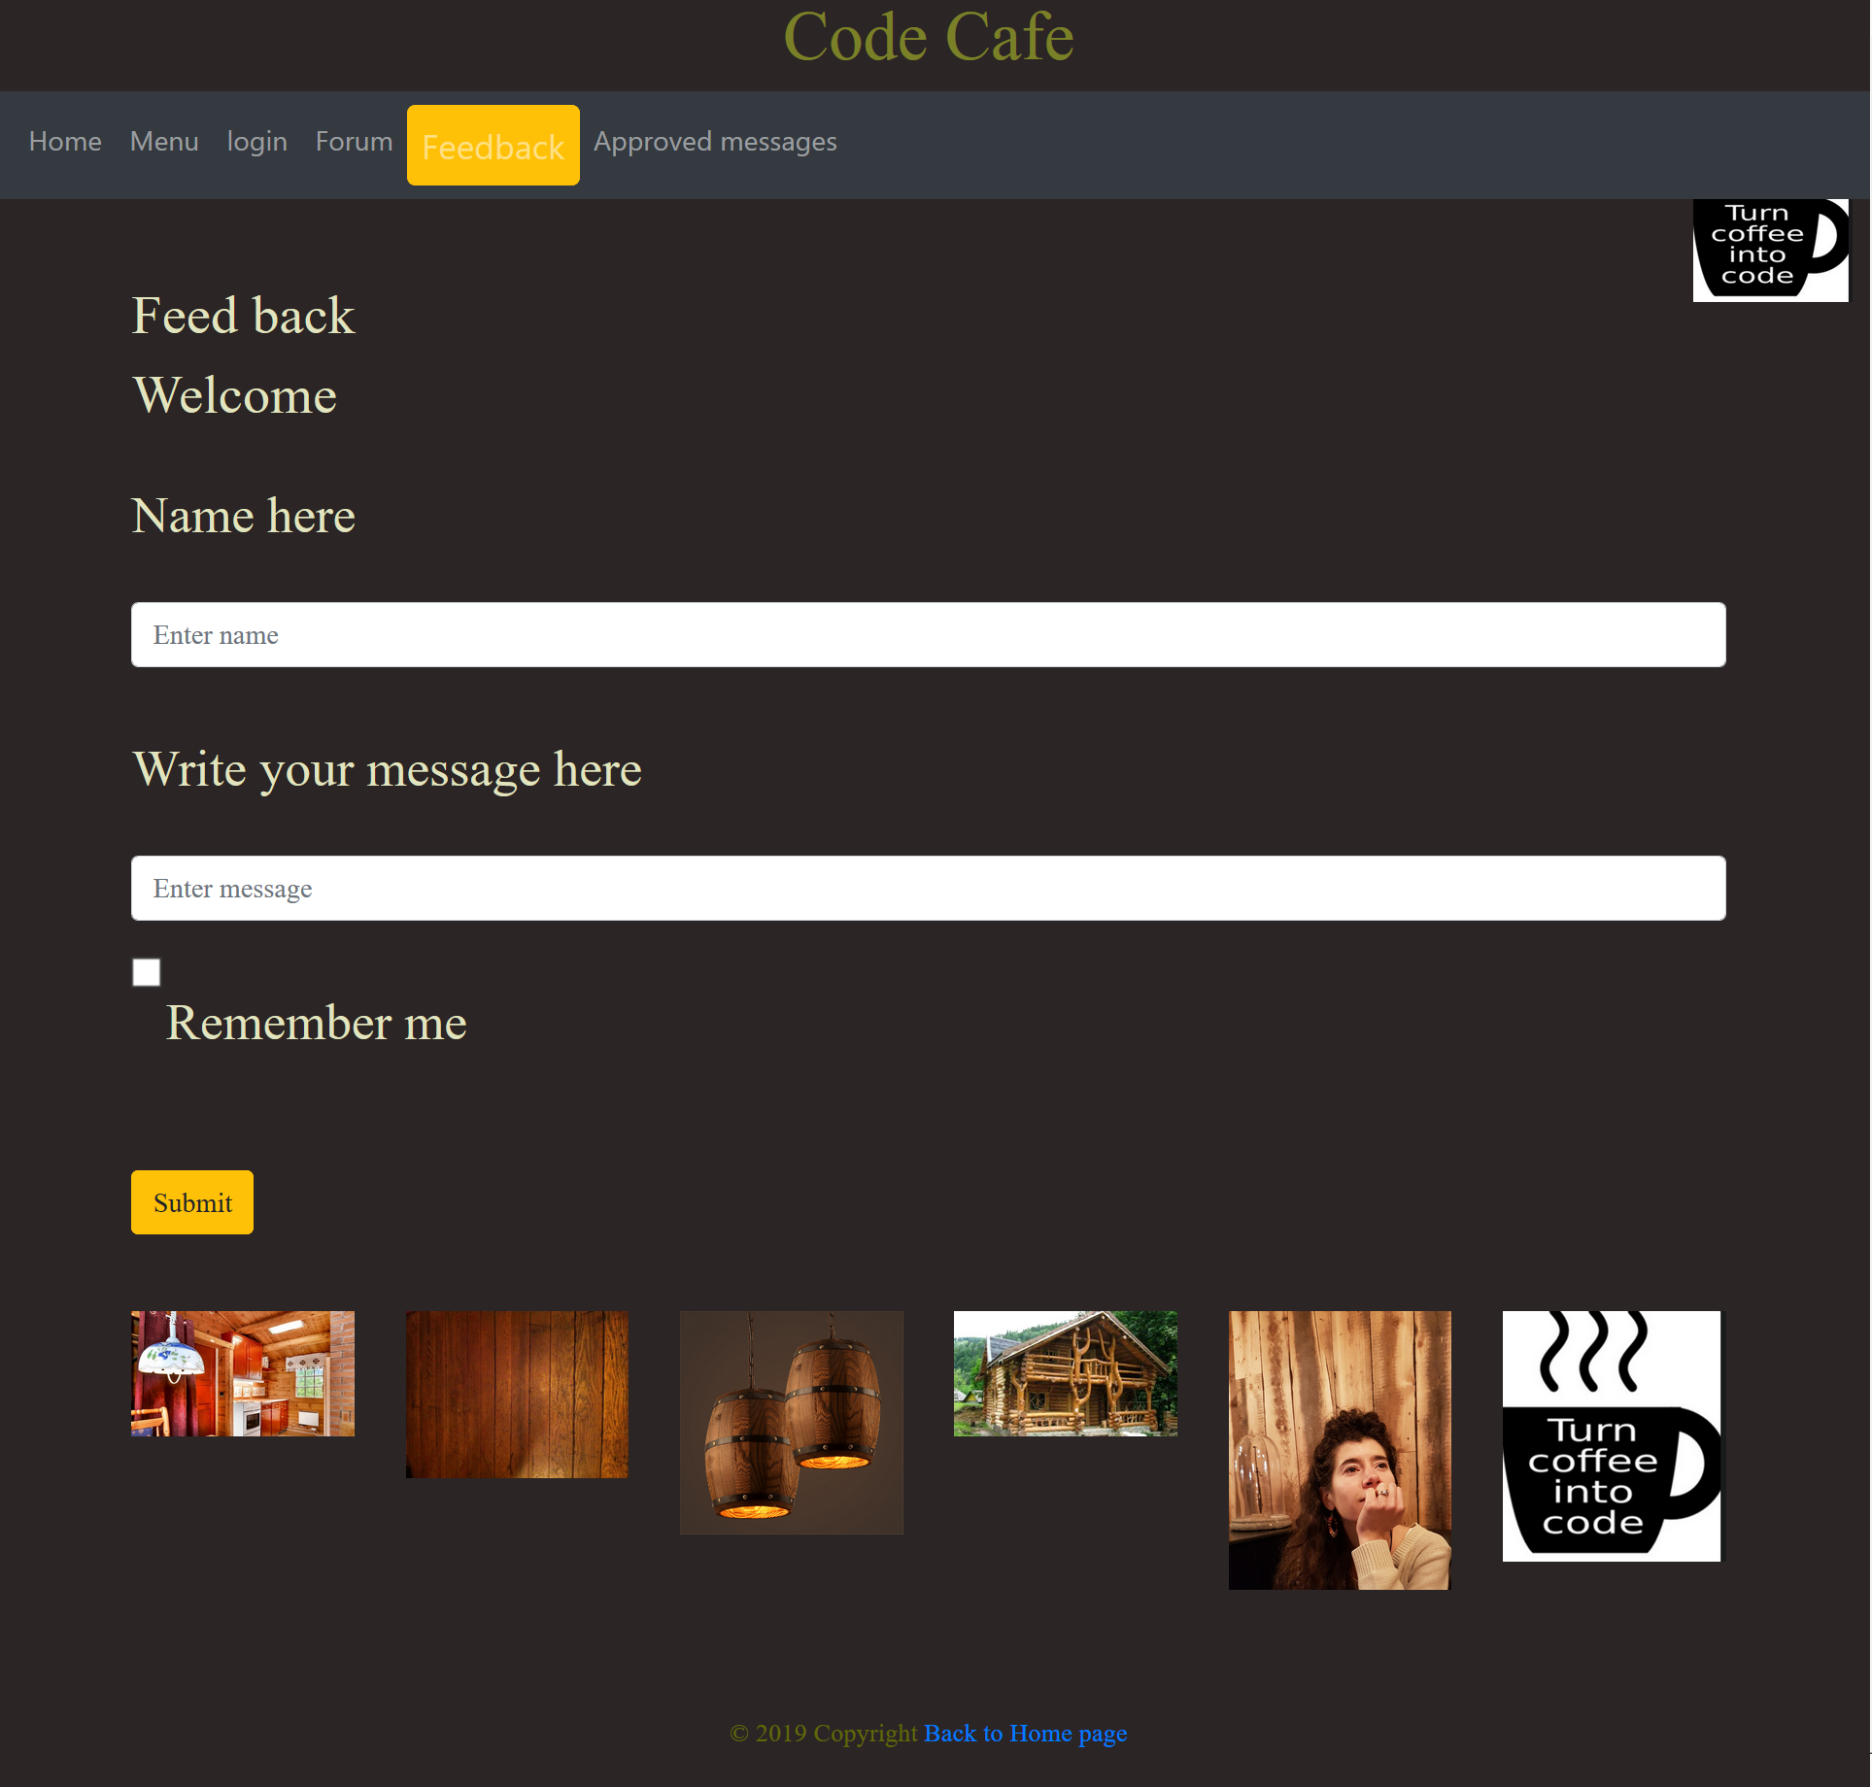 Tablet: Approved messages:

Desktop: Approved messages:

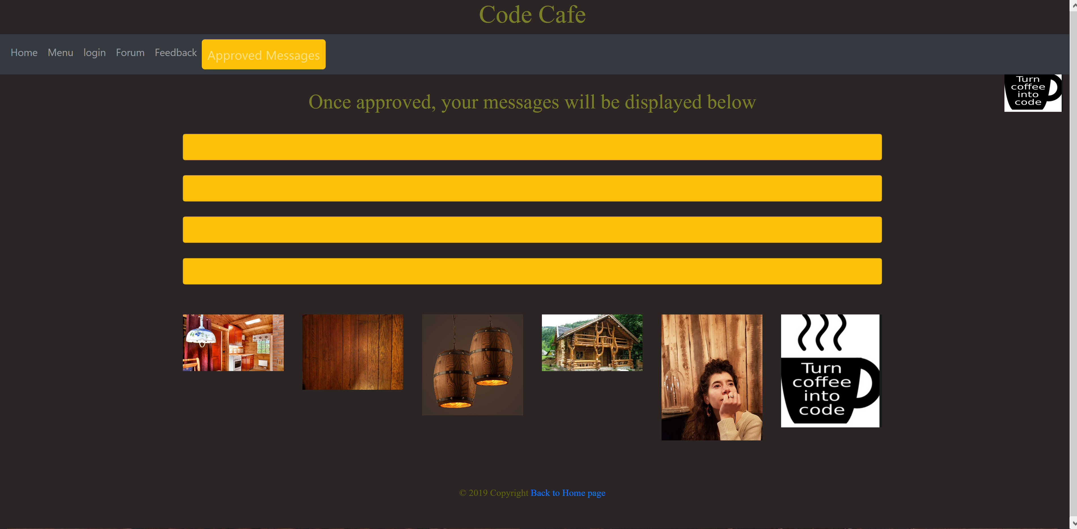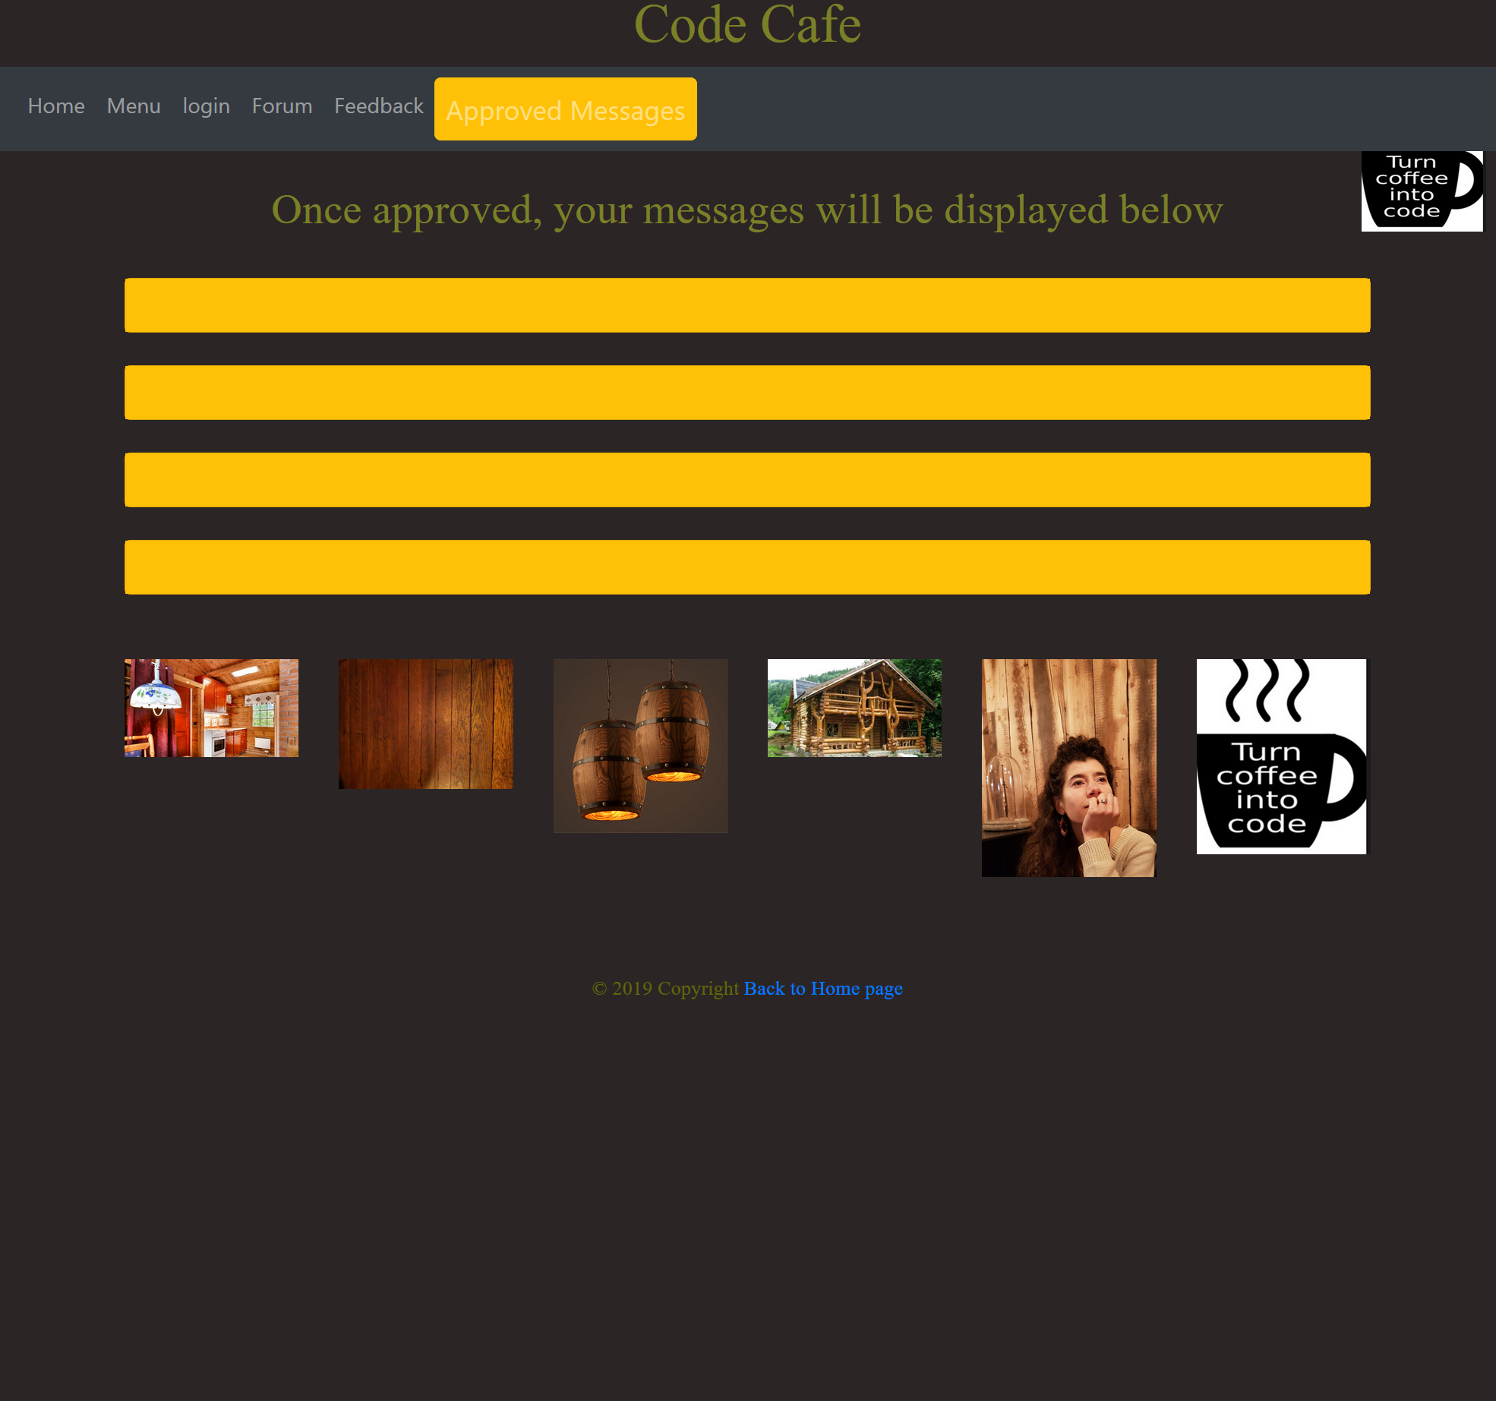

## Mobile Hi-Fi Wireframe – the responsive changes:

Phone has the hamburger-menu and goes red-background if less than 700px:

Footer photos enlarge.

Home; Menu; and Form pages in phone view.

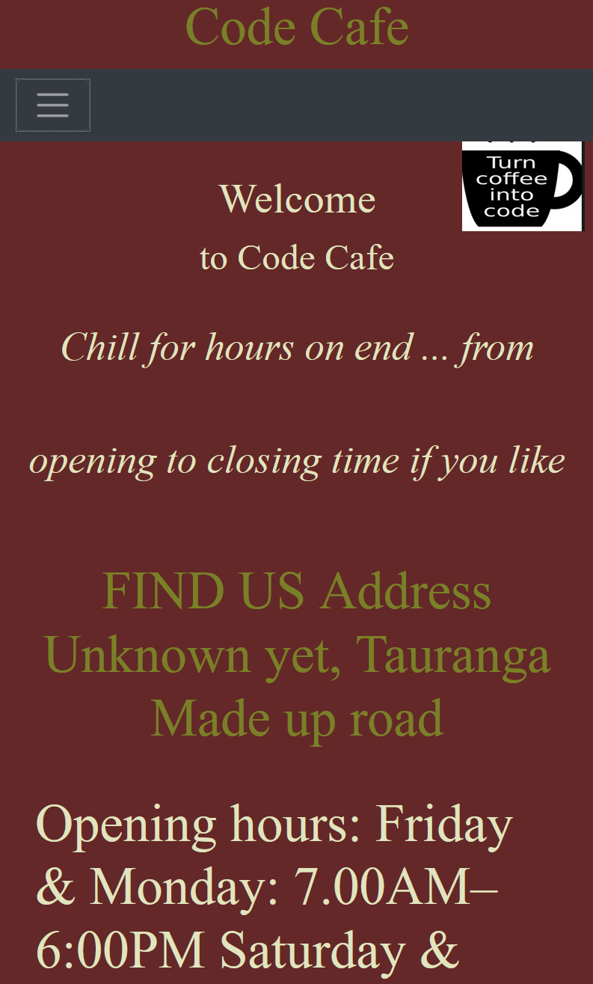 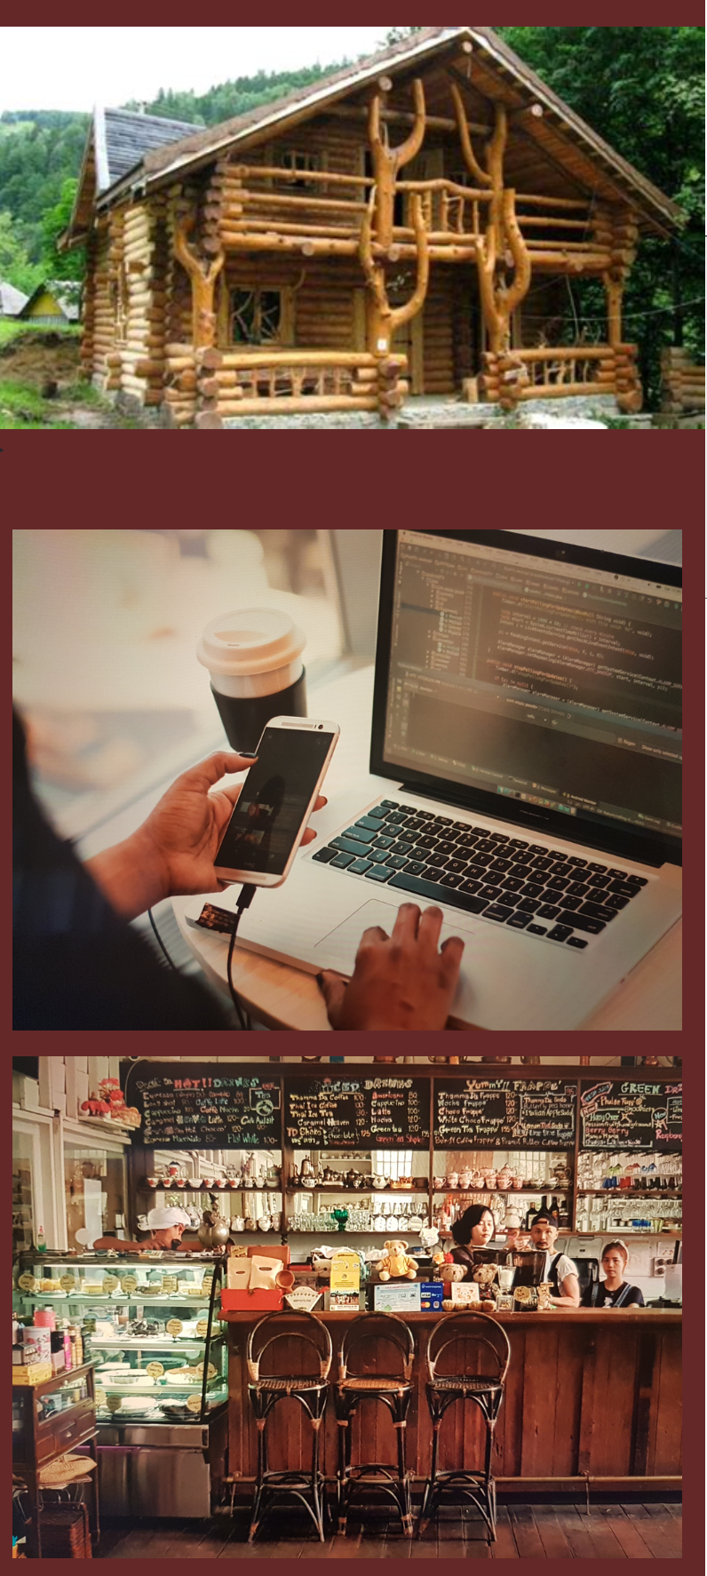 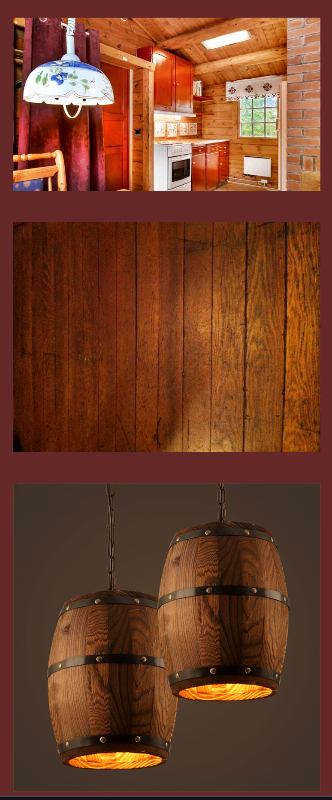  

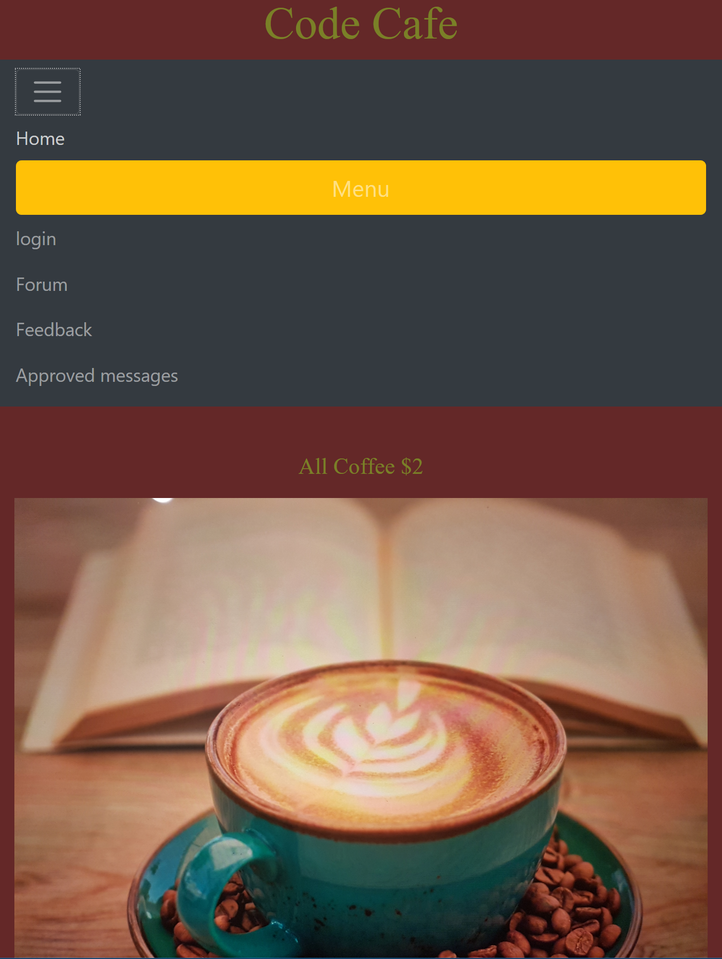 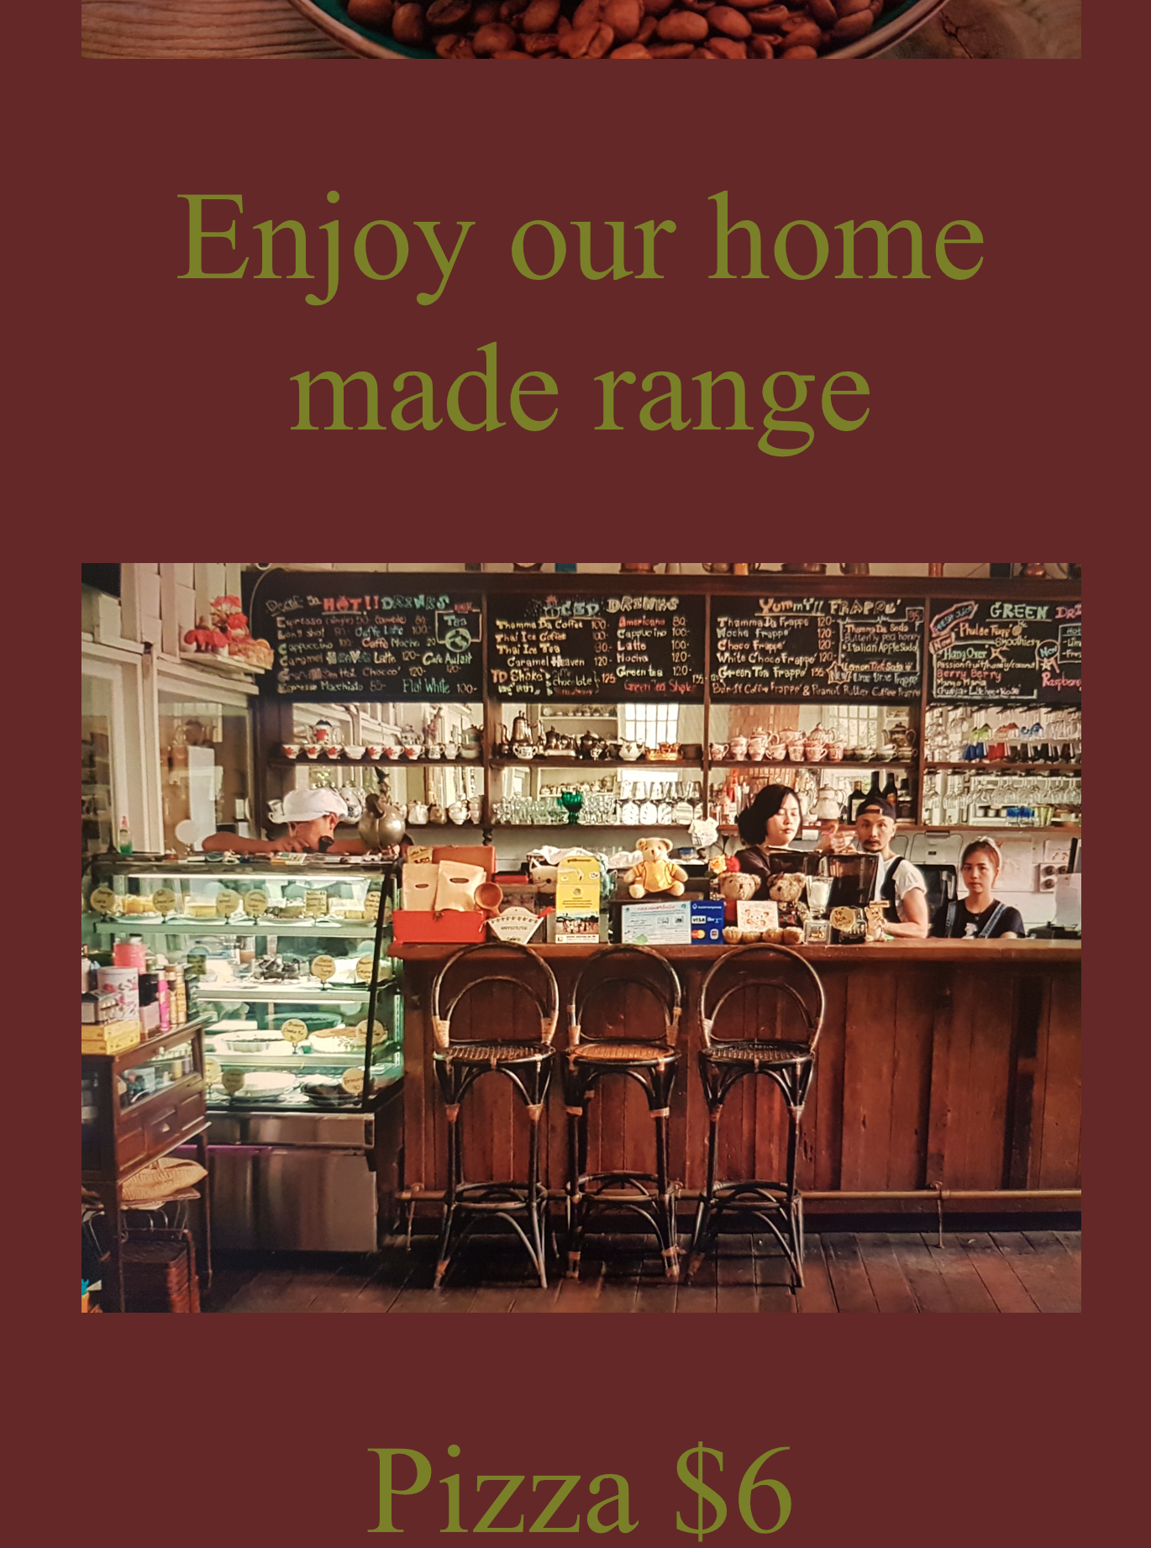 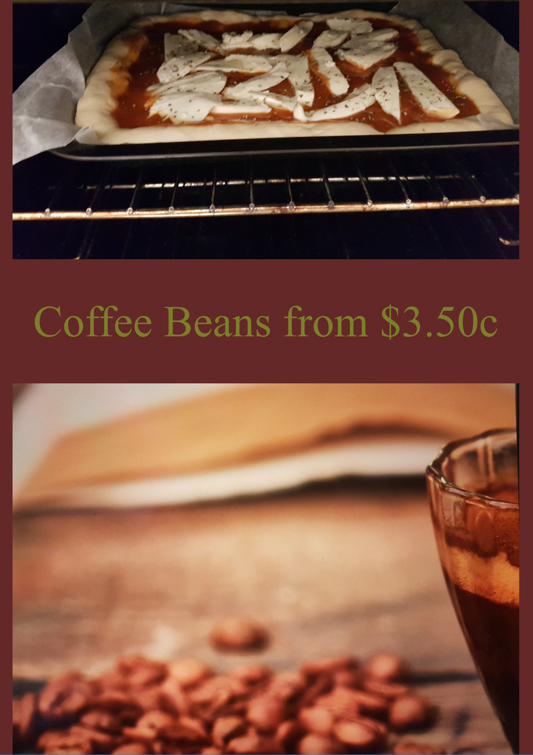 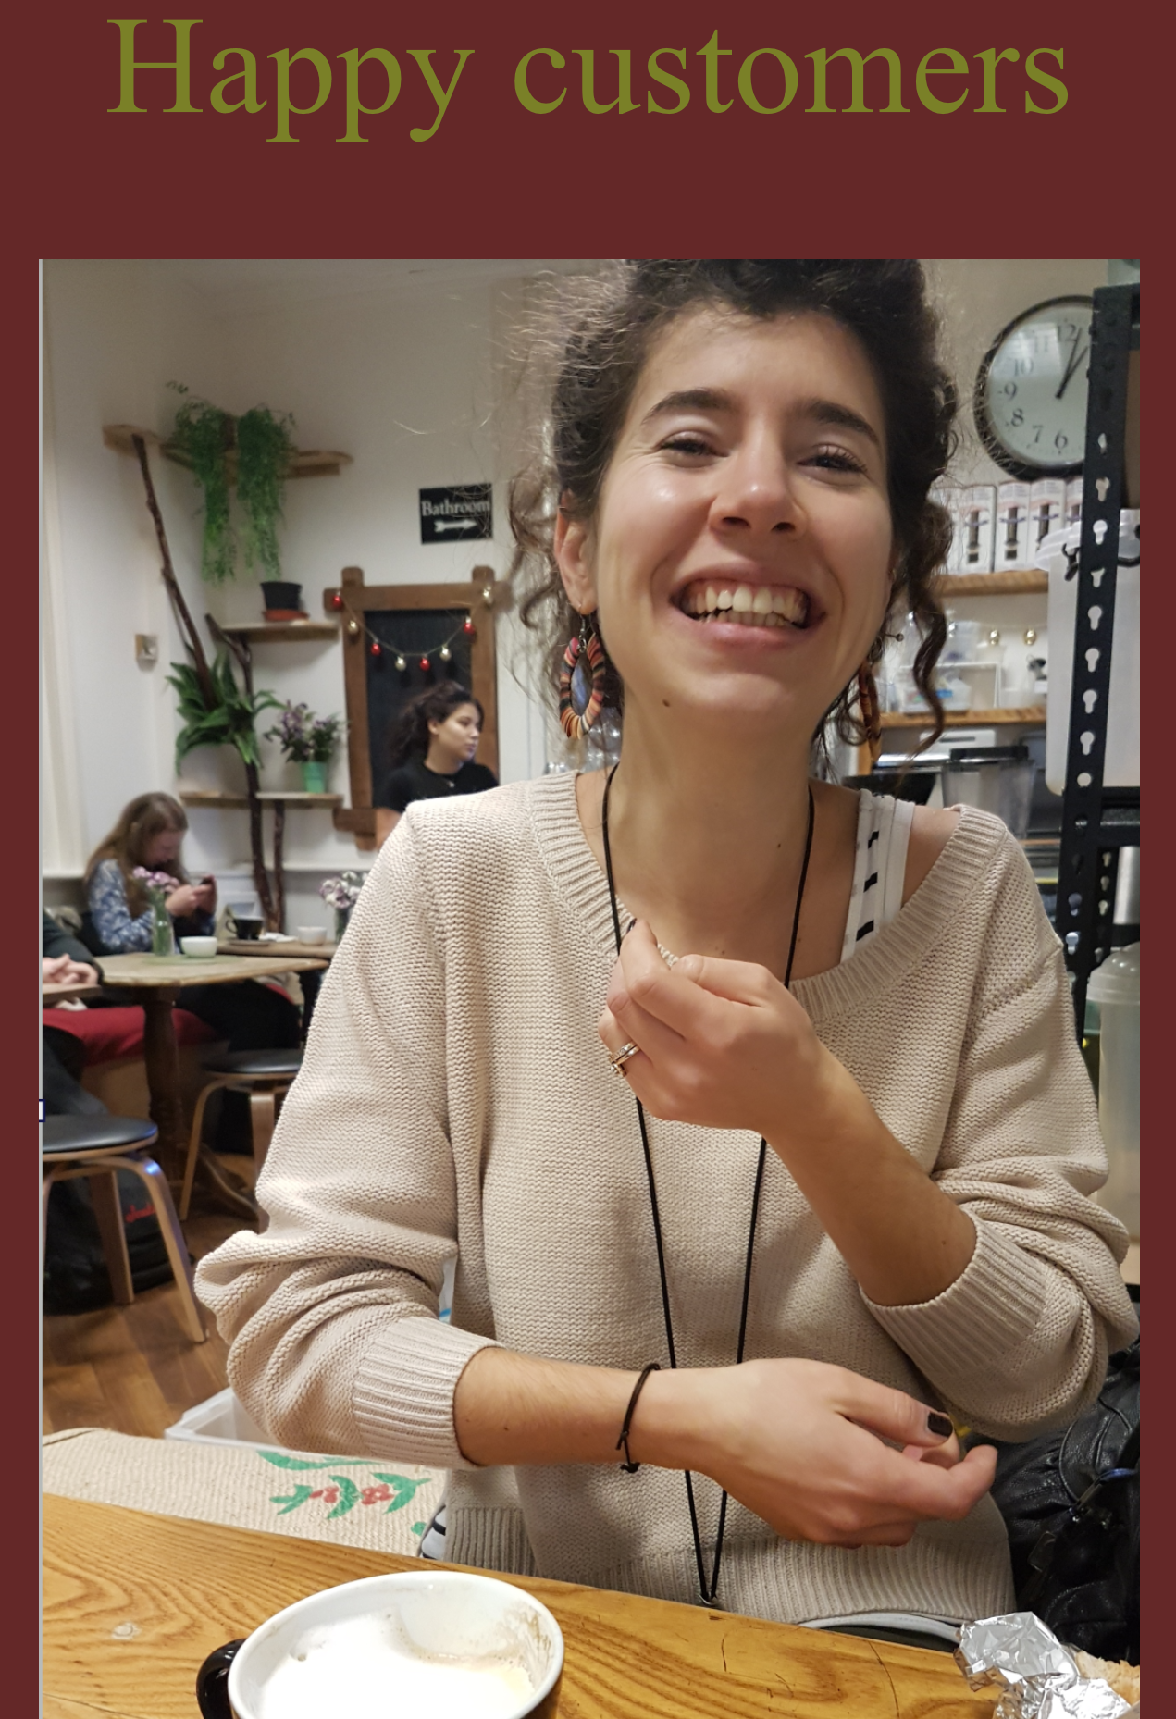

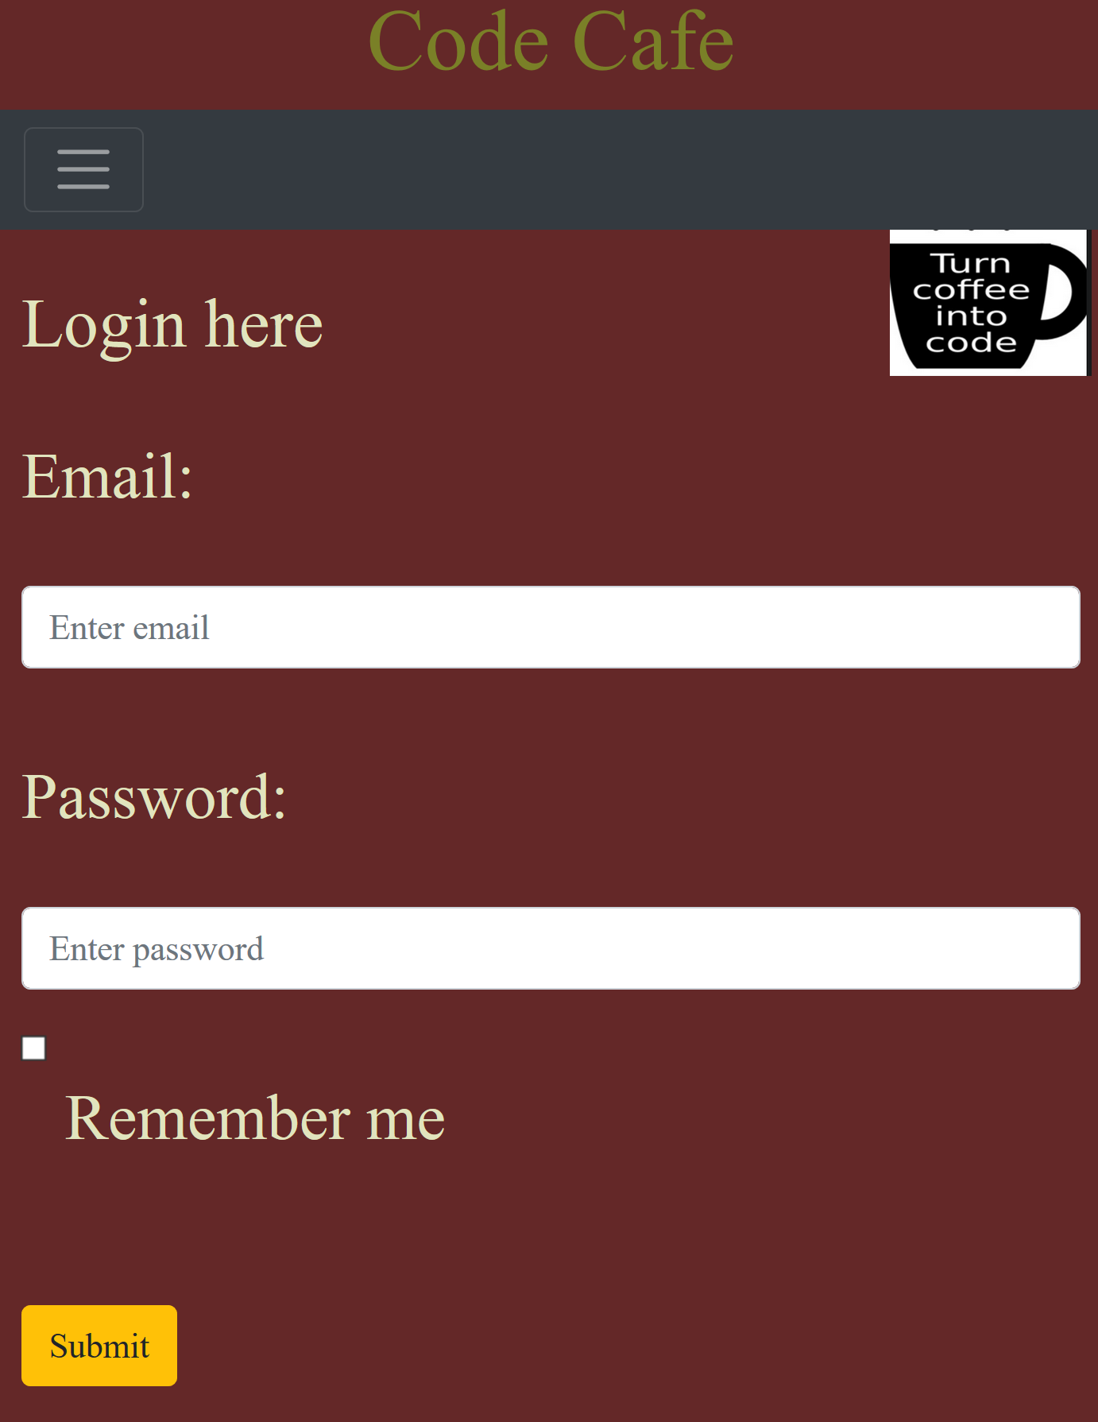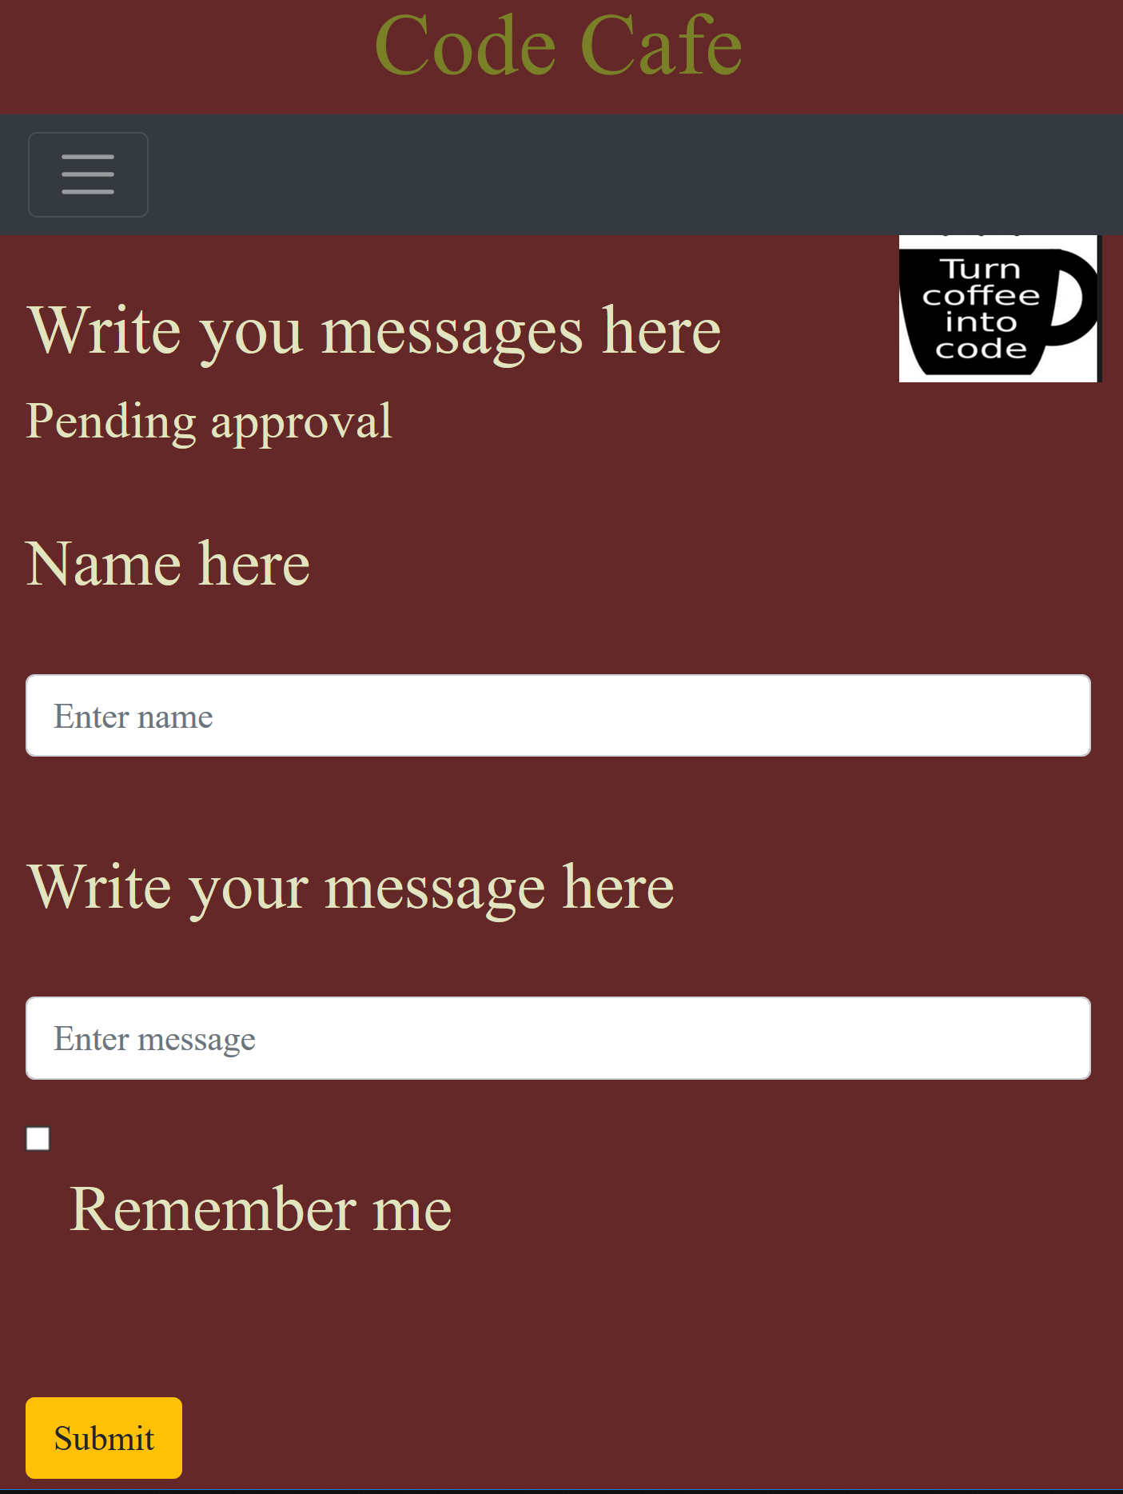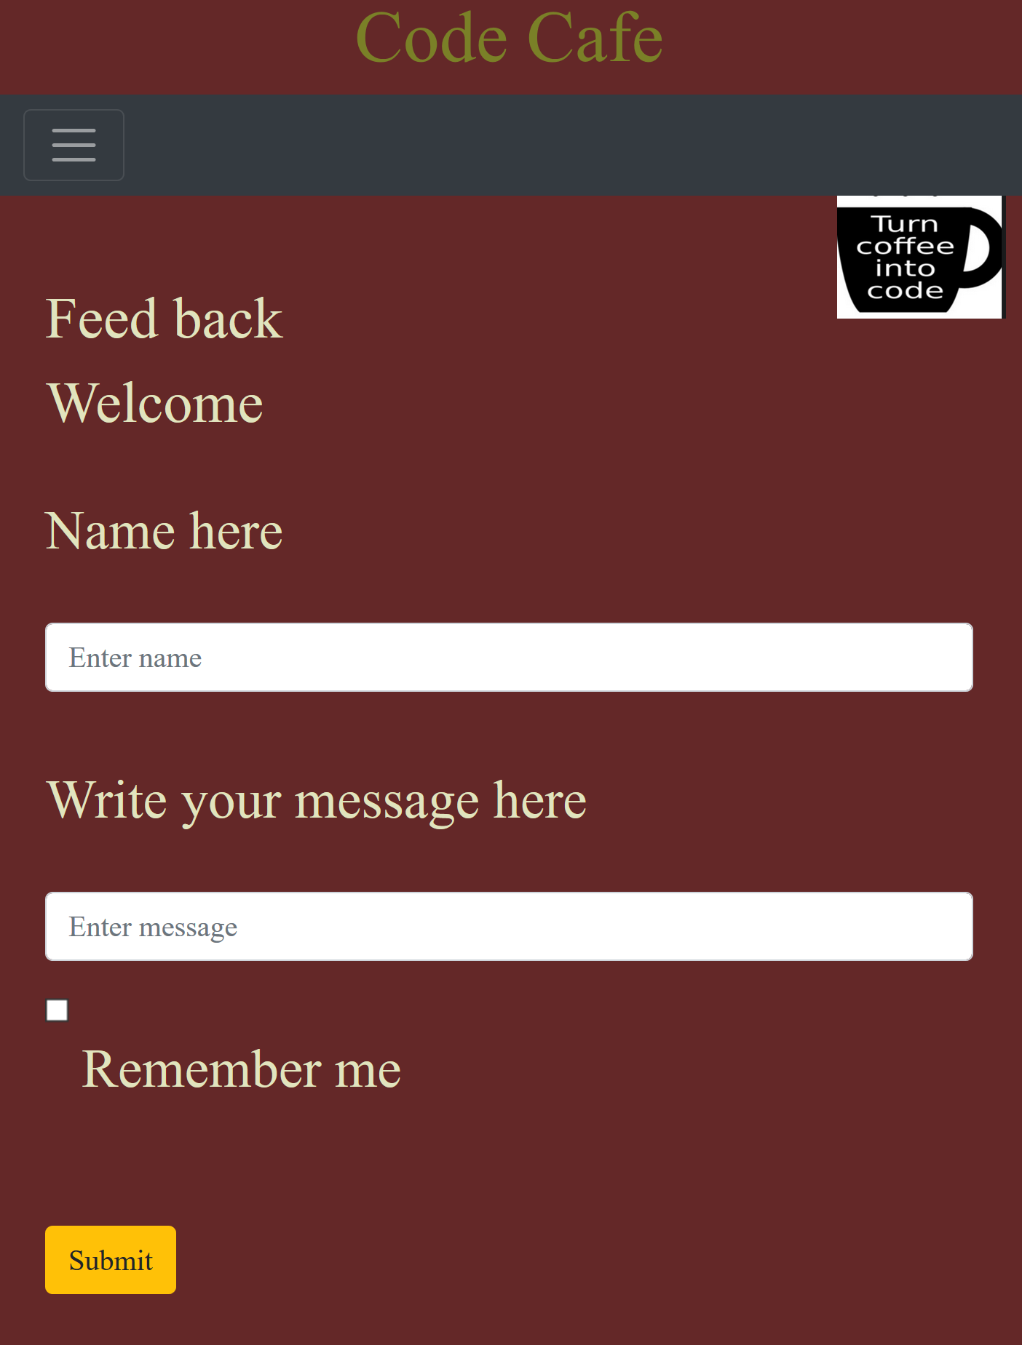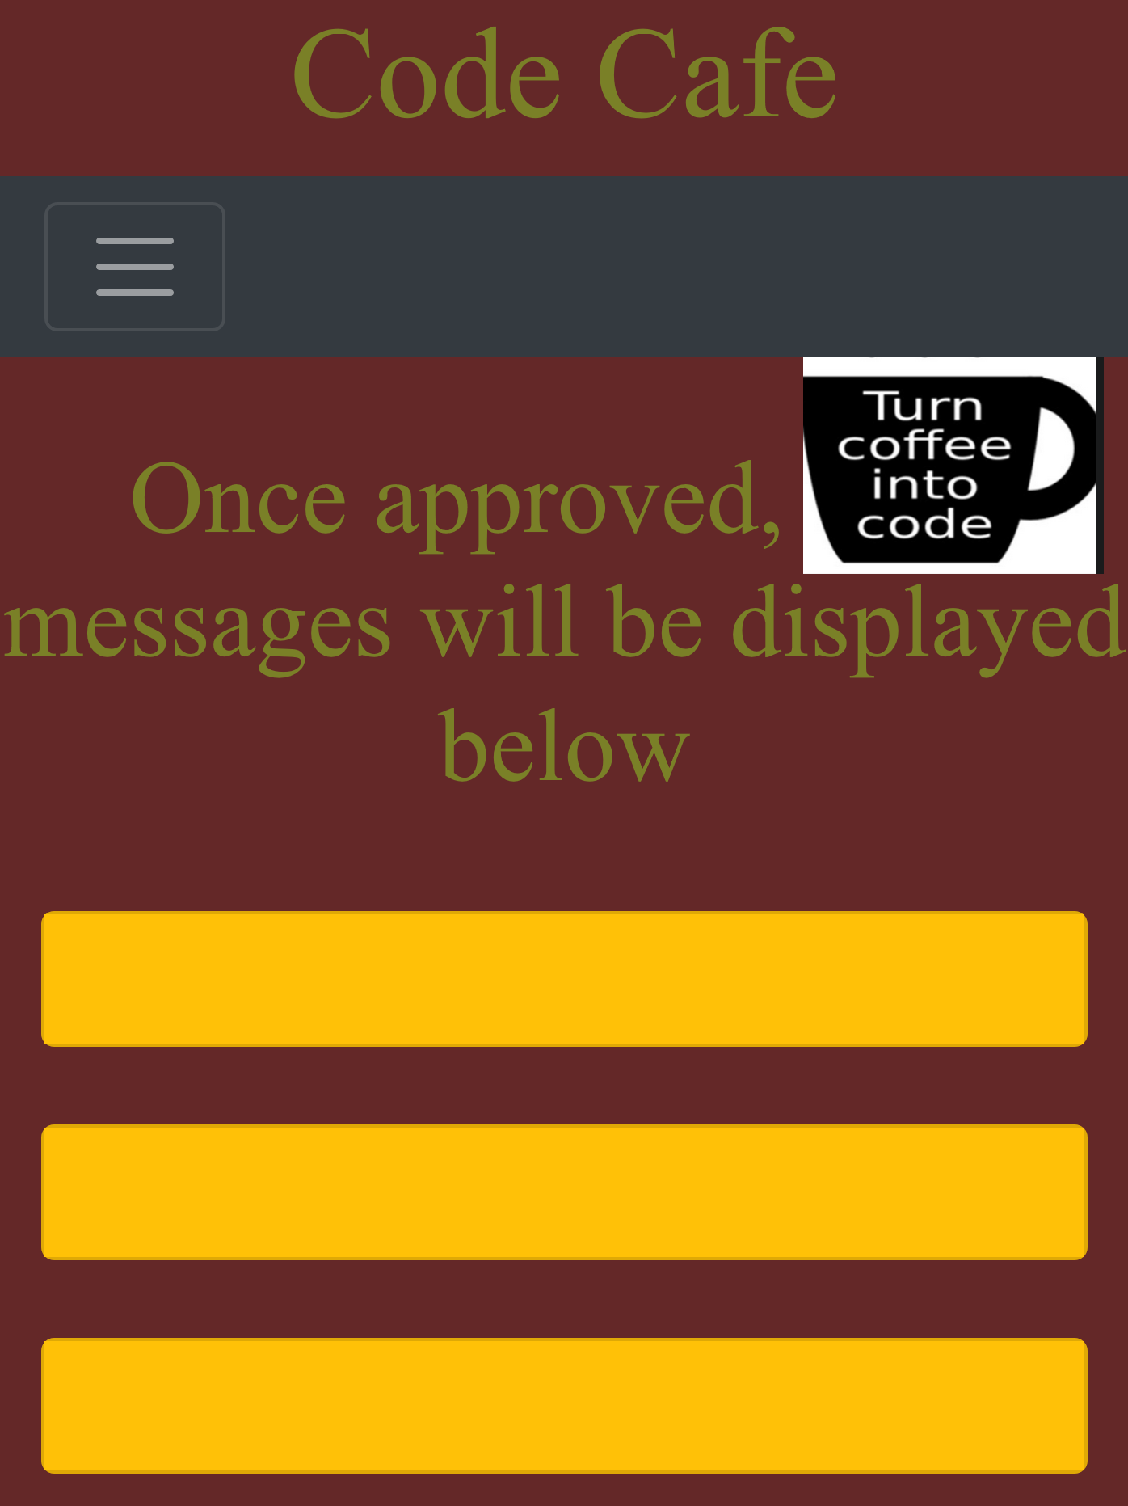

## Pages added:

Register page added (and responsive).

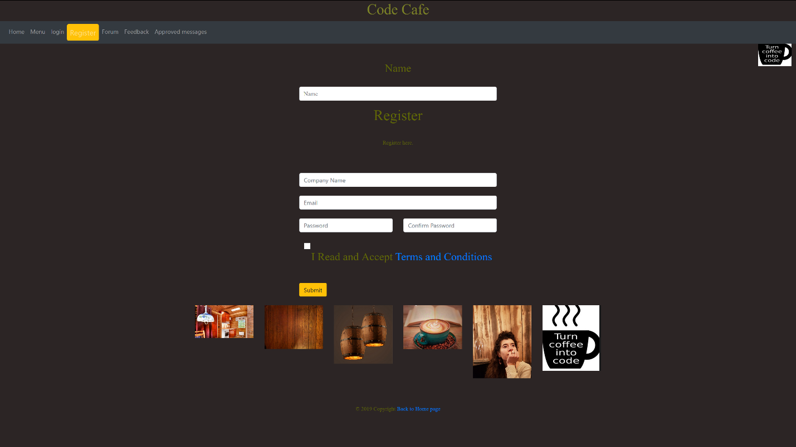

Placeholder page added for when buttons are clicked on. This edit page will be deleted and replaced with PHP.

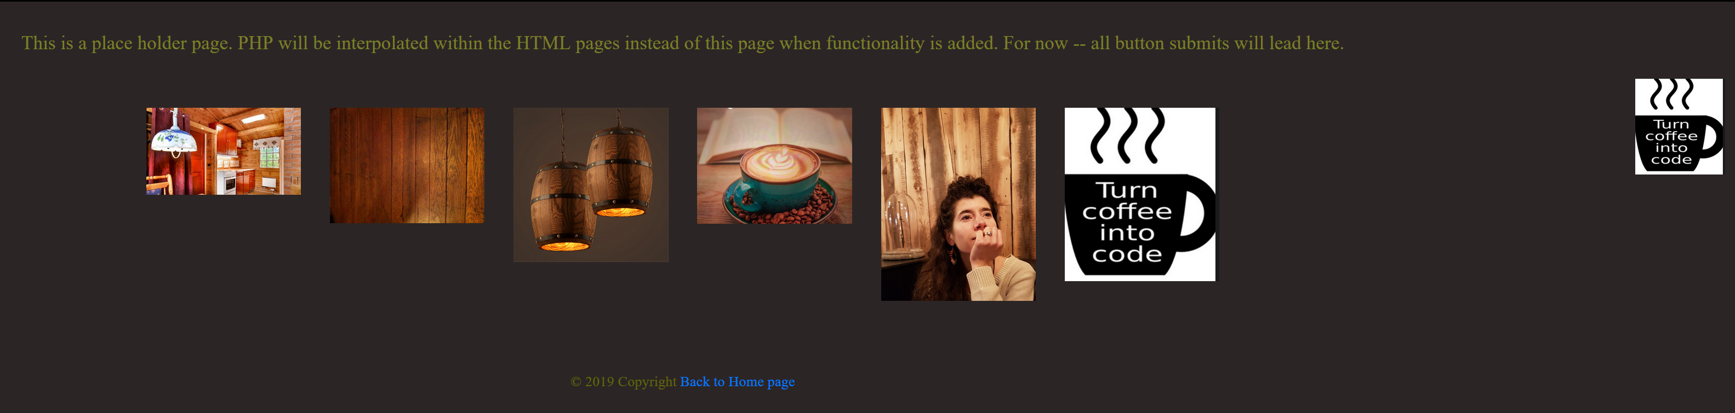

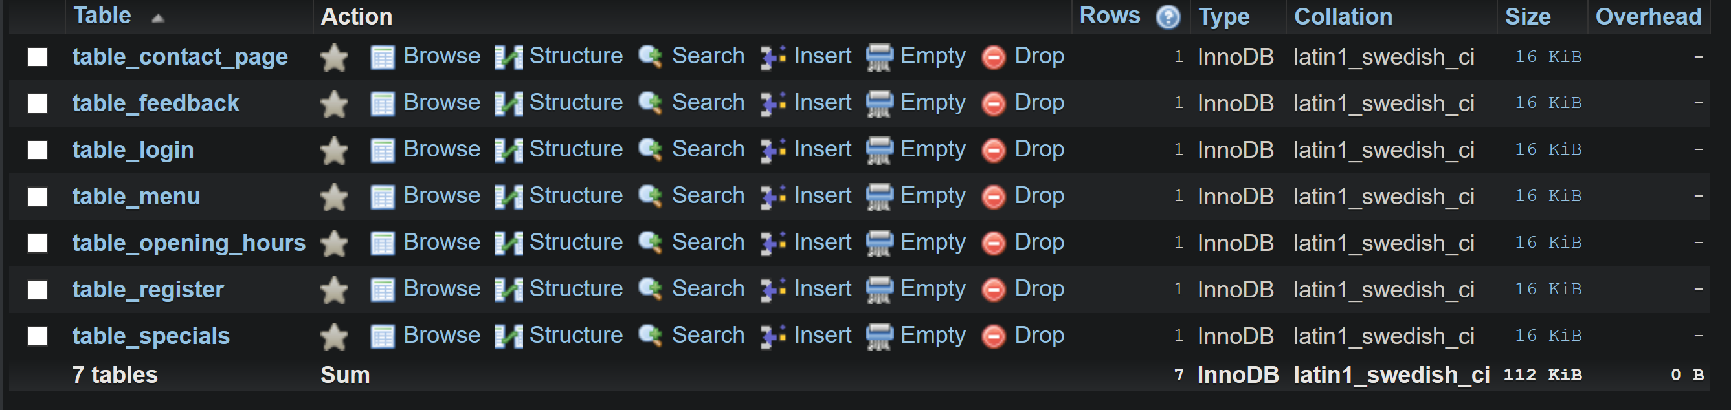

My database is called: luke_assignmentdb_with_rego

## SQL

--assignment1 luke fox 30011364

use luke_assignmentdb;

CREATE TABLE IF NOT EXISTS table_contact_page

 (

    ID VARCHAR(255),

    NAMES VARCHAR(255) NOT NULL,

    MESSAGES VARCHAR(255) NOT NULL,

    EMAIL VARCHAR(255)

    PRIMARY KEY (ID)

);

CREATE TABLE IF NOT EXISTS table_feedback

(

    ID VARCHAR(255),

    FEEDBACKTITLE VARCHAR(255) NOT NULL,

    FEEDBACK VARCHAR(255) NOT NULL,

    PRIMARY KEY (ID)

);

CREATE TABLE IF NOT EXISTS table_login

 (

    ID VARCHAR(255),

    ADMIN_LOGIN VARCHAR(255) NOT NULL,

    ADMIN_PASSWORD VARCHAR(255) NOT NULL,

    PRIMARY KEY (ID)

);

CREATE TABLE IF NOT EXISTS table_opening_hours

 (

    ID VARCHAR(255),

    OPEN_HOURS VARCHAR(255) NOT NULL,

    OPEN_DAYS VARCHAR(255) NOT NULL,

    PRIMARY KEY (ID)

);

CREATE TABLE IF NOT EXISTS table_menu

(

    ID VARCHAR(255),

    MENU_ITEM VARCHAR(255),

    ITEM_PRICE VARCHAR(255),

    PRIMARY KEY (ID)

);

CREATE TABLE IF NOT EXISTS table_specials

(

    ID VARCHAR(255),

    SPECIAL_ITEM VARCHAR(255),

    SPECIAL_PRICE VARCHAR(255),

    PRIMARY KEY(ID)

);

CREATE TABLE IF NOT EXISTS table_register

(

    ID VARCHAR(255),

    NAMES VARCHAR(255),

    COMPANY_NAME VARCHAR(255),

    REGO_EMAIL VARCHAR(255),

    REGO_PASSWORD VARCHAR(255),

    CONFIRM_REGO_PASSWORD VARCHAR(255),

    TERMS_AND_CONDITIONS VARCHAR(255),

    SUBMIT VARCHAR(255)

);

--assignment

-- trying to make a SQL file for assignment 1

--Contact page (name, email and message form) -- table 1:

INSERT INTO table_contact_page (ID, NAMES, EMAIL, MESSAGES) VALUES (uuid(), 'Name here', 'email here', 'message here');

--Feedback form (name, message and rating)    -- table 2:      uuid: that's manual ID

INSERT INTO table_feedback (ID, FEEDBACKTITLE, FEEDBACK) VALUES (uuid(), 'subject here', 'feedback here');

--The owner can login and change ALL of the content except the navbar and header. table 3 -- login -- no CRUD because not needed

INSERT INTO table_login (ID, ADMIN_LOGIN, ADMIN_PASSWORD) VALUES (uuid(), 'admin username here', 'admin password here');

--Opening hours table: 3

INSERT INTO table_opening_hours (ID, OPEN_HOURS, OPEN_DAYS) VALUES (uuid(), 'open hours are', 'open days are');

-- Menu table: 4

INSERT INTO table_menu (ID, MENU_ITEM, ITEM_PRICE) VALUES (uuid(), 'the menu item', 'menu item price');

--Speicals menu table: 5

INSERT INTO table_specials (ID, SPECIAL_ITEM, SPECIAL_PRICE) VALUES (uuid(), 'special item', 'special price');

--Register page. Table 6:

INSERT INTO table_register (ID, NAMES, COMPANY_NAME, REGO_EMAIL, REGO_PASSWORD, CONFIRM_REGO_PASSWORD, TERMS_AND_CONDITIONS, SUBMIT)

    VALUES (uuid(), 'name here', 'company name here', 'rego here', 'rego password', 'confirm rego here', 'terms and conditions here', 'submit here');

## ERD

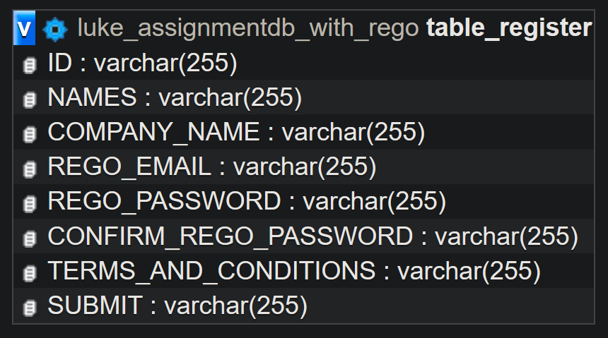 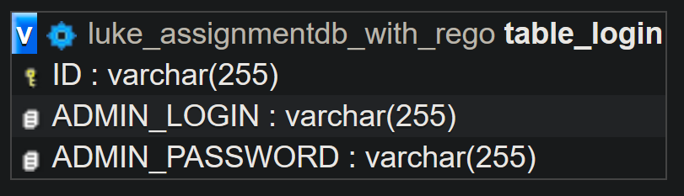

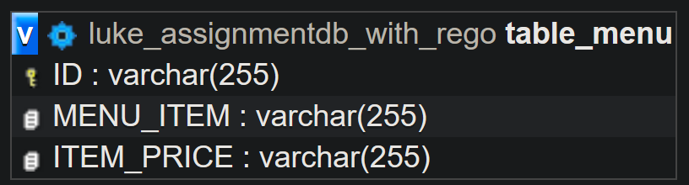 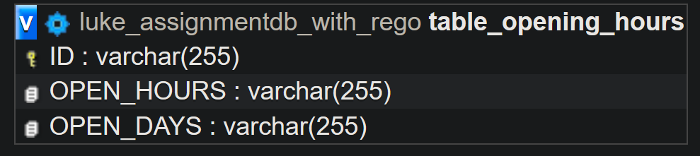

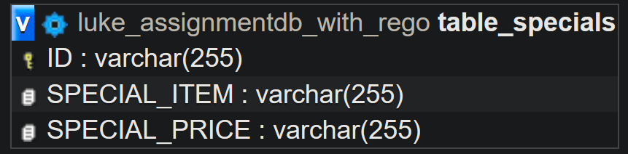

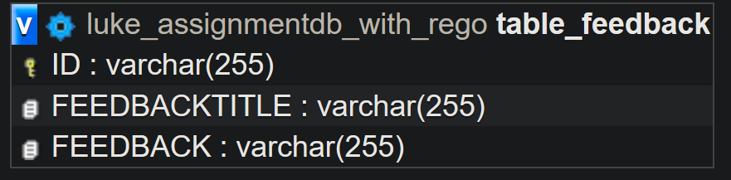 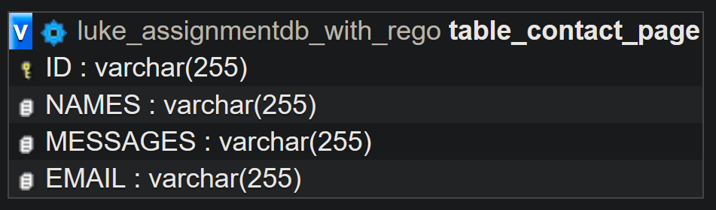

## Site Map of website showing links between pages

## Mood board

CSS used to convey café in the woods/wooden café feel.

.Logo {

  position: absolute;

  width: 93px;

  height: 99px;

  right: 10px;

  top: 80px;

}

.myFont {

  font-family: Rochester;

  font-style: normal;

  font-weight: normal;

  font-size: 20px;

  line-height: 86px;

  text-align: center;

  color: #7a8027;

}

.myFont2 {

  font-family: Rochester;

  font-style: normal;

  font-weight: normal;

  font-size: 30px;

  line-height: 86px;

  text-align: left;

  color: #e1e4be;

}

.myFont3 {

  font-family: Rochester;

  font-style: normal;

  font-weight: normal;

  font-size: 15px;

  line-height: 86px;

  text-align: center;

  color: #606806;

}

.radio-wrapper {

  display: inline-block;

}

.radio-wrapper * {

  float: right;

}

.radio-wrapper > input {

  display: none;

}

label {

  font-size: 30px;

}

input:checked~label {

  color: #e4f802

}

/* Media Queries*/

.custom-class {

  display: none;

}

body {

  background-color: rgb(44, 37, 37);

}

@media only screen and (max-width: 700px) {

  body {

    background-color: rgb(100, 40, 40);

  }

}

Moodboard – The photos depict a coffee and wood smelling place with a warm feel from the fire and mellow/jazzy background music for a relaxing study/eating mood.

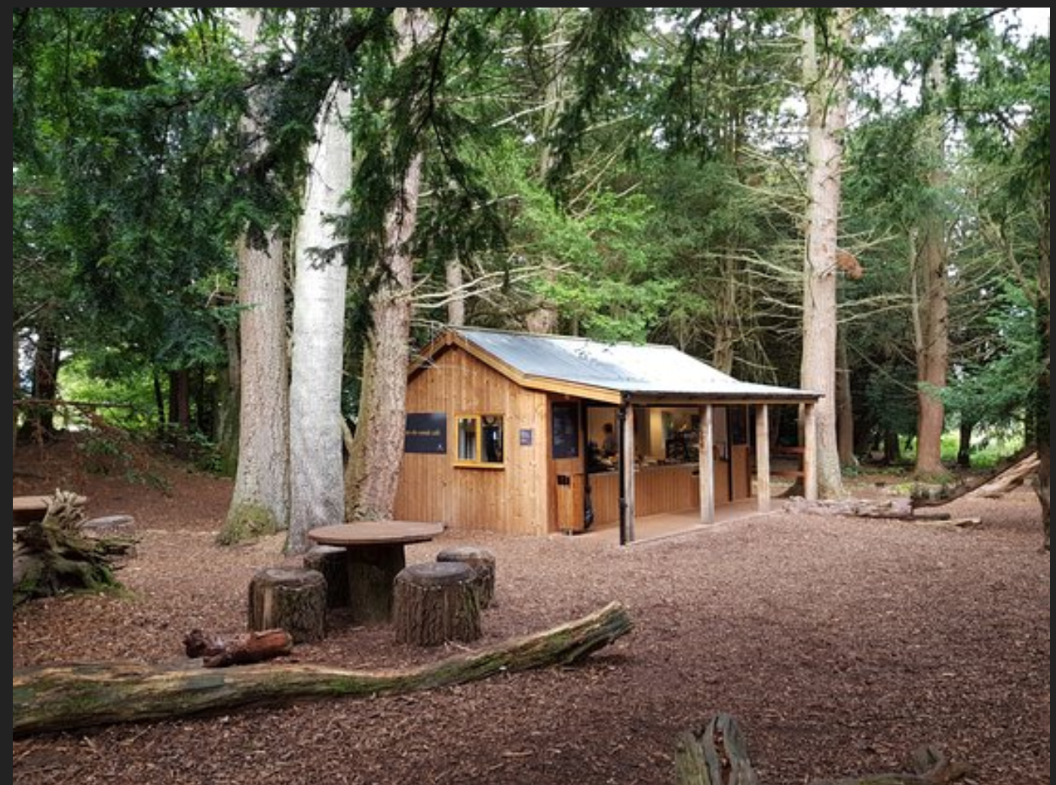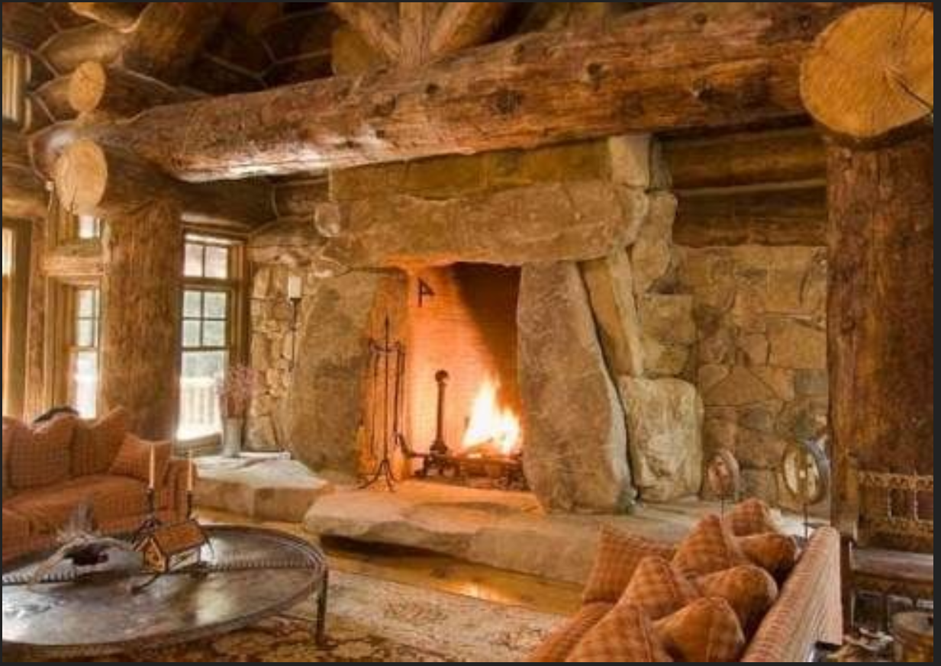

## Storyboard (sequence of events)

Login



If unable to login. An error message will appear.

If successful a successful message will appear.

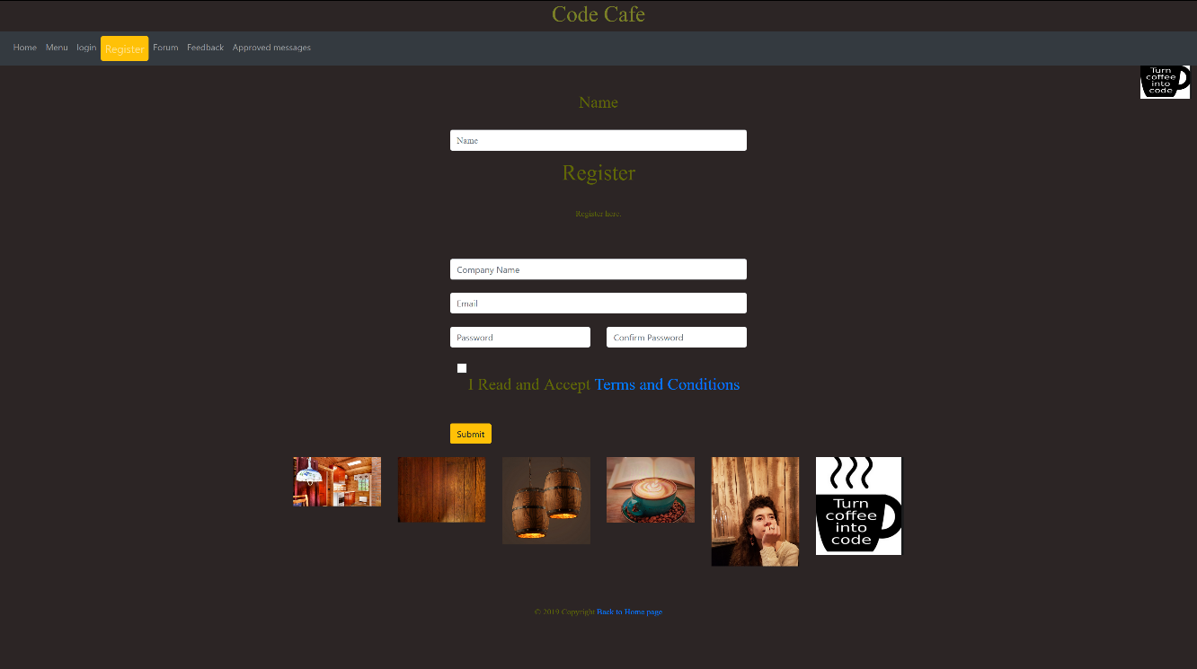

Register: If a box is not filled out or terms and conditions not checked. An error message will appear; if filled out, success message will appear.

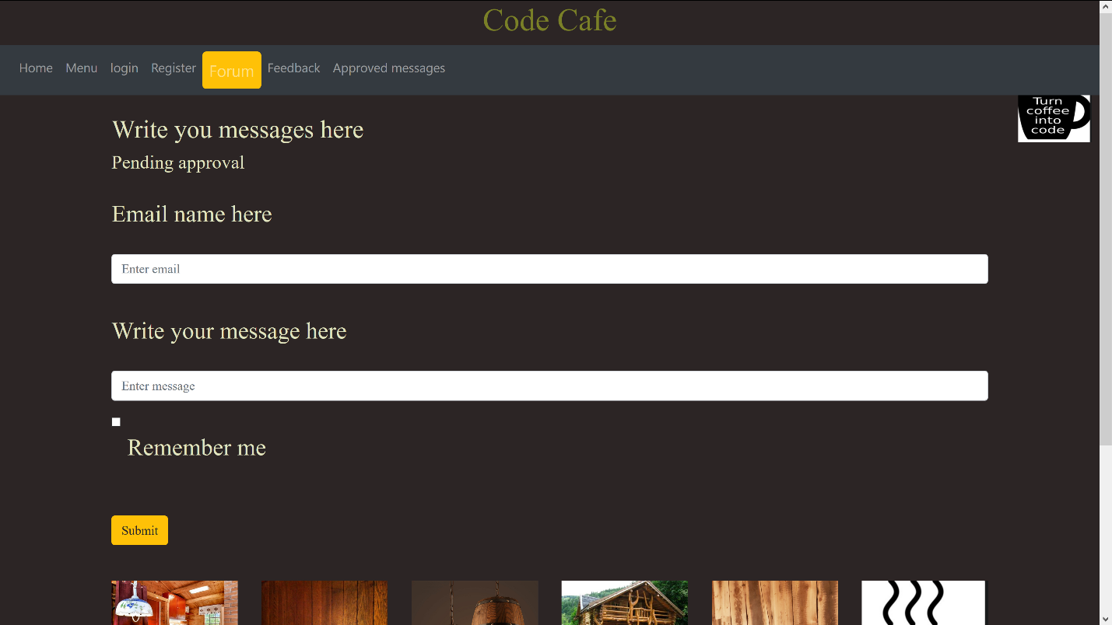

When the user enters their email, they will be able to see their message on approved messages page.



At the moment there are no approved messages. They will appear instead of these place-holder yellow lines.

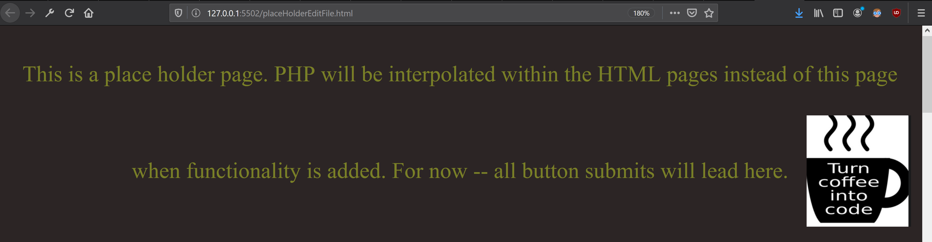

Lastly, this is a placeholder.html page for button submits or impending PHP. This will be gone for assignment-two and replaced with proper redirects.

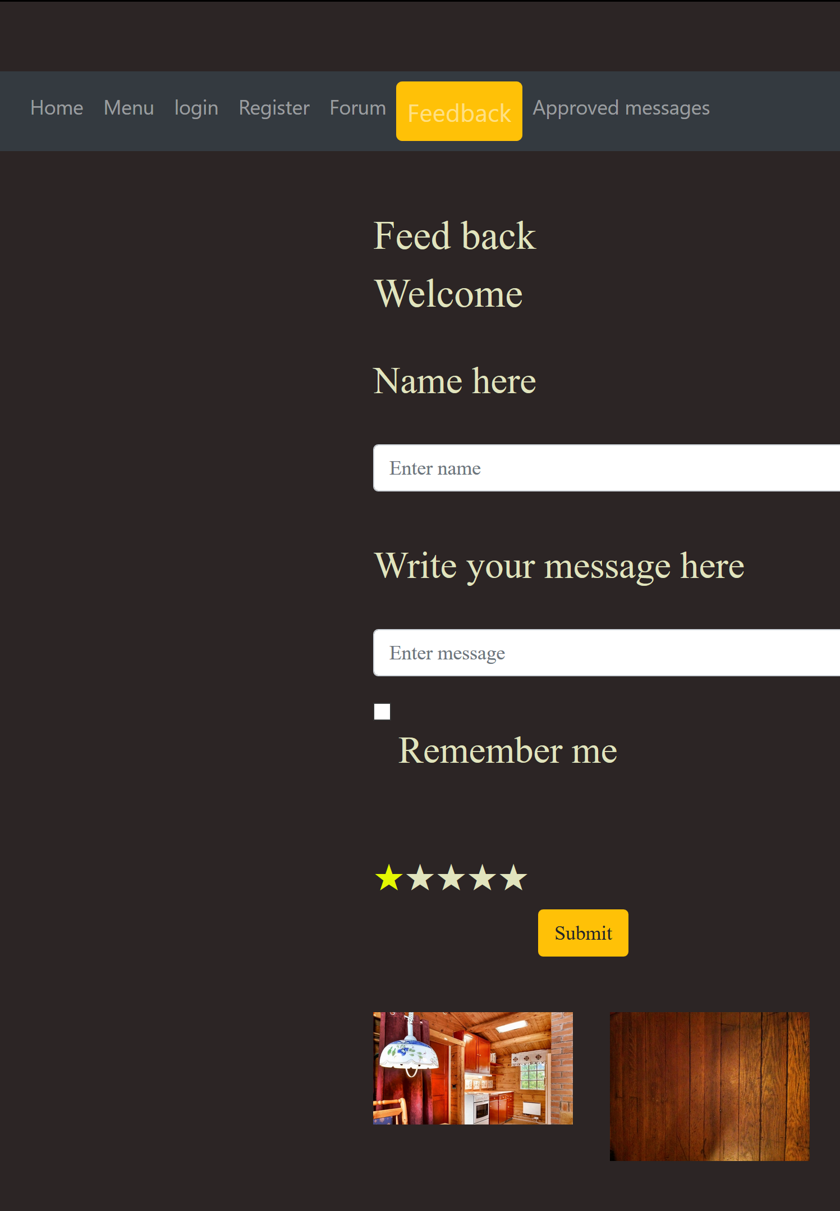

Example feedback message: I have given this website a one yellow star because the coffee was over 70degress Celsius.



Lastly, this is a placeholder.html page for button submits or impending PHP. This will be gone for assignment-two and replaced with proper redirects.

## Flow diagram to show all the actions that can be taken on your site.

(True is down. False is across.)

Home

Is logged in?

Go to

False

Register

True

Menu

Go to another page

Is logged in as owner

Browse menu

Can change items and prices

Forum

Email and Message supplied?

Message submitted but waiting approval

Go to another page

User can see approved messages.

# 

Feedback

All fields filled out correctly?

Stay on page

Go to

Has chosen a 1-5 star rating?

Submitted for approval

# Part C: Testing Document

Testing Website: Cafe Code

Questions:

Q.: Is the website responsive?

Q.:  Does it work in Chrome?

Q.:   Does it work in any other browser?

Q.:   Do the colours match the Moodboard?

Q.:   Do all the images load on the testers machine?

Q.:   Is the website HTML validated?

Q.:   Is the website CSS validated?

Q.: SQL file executed without errors?

Q.: PHP or .php extensions used?

Q.: Webpages match the wireframe?

Q.: Framework / Libraries used in project?

Questions and Answers:

Testers name: Villi

 Q.:   Is the website responsive?

    A.: Yes

 Q.:    Does it work in Chrome?

    A.: Yes

 Q.:   Does it work in any other browser?

    A.: Yes. Firefox

 Q.:   Do the colours match the Moodboard?

    A.: Yes

 Q.:   Do all the images load on the testers machine?

    A.: Yes

Q.:   Is the website HTML validated?

    A.: Yes using https://validator.w3.org

Q.:   Is the website CSS validated?

    A.: Yes using https://validator.w3.org

Q.: SQL file executed without errors?

    A.: Yes using PHPmyAdmin (delete the comments before or after pasting in).

Q.: PHP or .php extensions used?

    A.: No

Q.: Webpages match the wireframe?

    A.: Yes

Q.: Framework / Libraries used in project?

    A.: Yes -- Bootstrap 4.

Testers name: Abi

Q.: Is the website responsive?

    A.: Yes

Q.:  Does it work in Chrome?

    A.: Yes

Q.:   Does it work in any other browser?

    A.: Yes

Q.:   Do the colours match the Moodboard?

    A.: Yes

Q.:   Do all the images load on the testers machine?

    A:. Yes

Q.:   Is the website HTML validated?

    A.: Yes

Q.:   Is the website CSS validated?

    A.: Yes

Q.: SQL file executed without errors?

    A.: Yes

Q.: PHP or .php extensions used?

    A.: No

Q.: Webpages match the wireframe?

    A.: Yes

Q.: Framework / Libraries used in project?

    A.: Yes

(Validator.w3.org, 2019).

# Reference

Synopsys (2019). *Agile-SDLC* retrieved from:

<https://www.synopsys.com/software-integrity/resources/knowledge-database/agile-sdlc.html>

Validator.w3.org (2019). Retrieved from:

<https://validator.w3.org/nu/#file>